

DATA STRUCUTRES AND ALGORITHMS

23CSE203

LAB MANUAL

Submitted by

Name | Md Rehan
Roll No | AV.SC.U4CSE25038
Year/Sem/Section | 2nd year/Sem-3/CSE-A
Credits | 05

Submitted to

Name | Dr. RAJ KUMAR BATCHU
Department | School of Computing
Designation | Asst. Professor (SI Grade)

S.NO | TITLE | REMARKS | PAGE NO
1. | WEEK 1: 1. Recursive countdown from n to Launch.  2. Recursive calculation of compound growth factor.  3. Recursive search for employee ID in list.  4. Recursive factorial calculation for parcel arrangements.  5. Recursive Fibonacci series generation. |  | 3 - 11
2. | WEEK 2: 1) write a python program to perform linear search on the given input.  2.a)write a python program to perform binary search on the given input verify by taking sorted array.  2.b) write a python program to perform binary search on the given input verify by taking unsorted array. |  | 12-18
3. | WEEK 3: 1.a) Write a python program to sort the elements using bubble sort technique. Take an input from the user.  1.b) Write a python program to sort the elements using insertion sort technique. Take an input from the user.  1.c) Write a python program to sort the elements using selection sort technique. Take an input from the user.  1.d) Write a python program to sort the elements using quick sort technique. Take an input from the user.  1.e) Write a python program to sort the elements using merge sort technique. Take an input from the user. |  | 19-25
4. | WEEK 4: Aim 4.a:Write a program to implement a single linked list which would perform the below operations, by taking an input from the user.  a)create a linked list  b)insert at beginning  c)insert at end  d)insert at a specified index  e)delete by value  f)delete 1st node  g)delete last node  h)count no.of nodes  i)display or traverse  j)search for a number  k)exit  Aim 4.b:Write a program to implement a double linked list which would perform the below operations, by taking an input from the user.  a)create a linked list  b)insert at beginning  c)insert at end  d)insert at a specified index  e)delete by value  f)delete 1st node  g)delete last node  h)count no.of nodes  i)display or traverse  j)search for a number  k)exit  Aim 4.c:Write a program to implement a circular linked list which would perform the below operations, by taking an input from the user.  a)create a linked list  b)insert at beginning  c)insert at end  d)insert at a specified index  e)delete by value  f)delete 1st node  g)delete last node  h)count no.of nodes  i)display or traverse  j)search for a number  k)exit |  | 26-61
5 | Week 5: Write a python program to implement a stack using an Array, Linked list. Implement the stack operations such as push, pop, peak and also display the stack elements. |  | 61-71
6 | Week 6: Write a python program to implement a queue using an Array, Linked list, circular queue. Implement the queue operations such as enqueue, dequeue, peek and also display the queue elements. |  | 71-85
7 | Week 7: a)write a python program to implement binary tree search using an array with all its operations.  b)write a python program to implement binary tree using an linked list with all its operations. |  | 85-98
8 | Week 8: write a python program to implement Binary tree with its operations using array and linked list. |  | 98-104
9 | Week 9: write a python code for AVL tree using array and linked list with all its operations. |  | 104-132

WEEK-1
1A.AIM:A Rocket launch system displays a countdown before launch. Instead of suing a loop, implement the countdown using recursion. Write a recursive python program to display a countdown from n to 1 followed by “launch”.
Code:
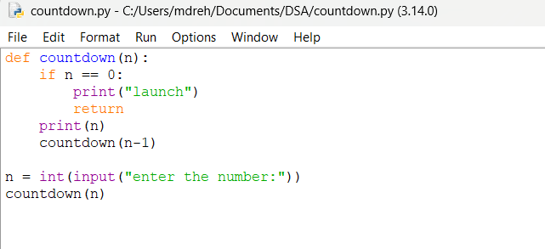
Output:

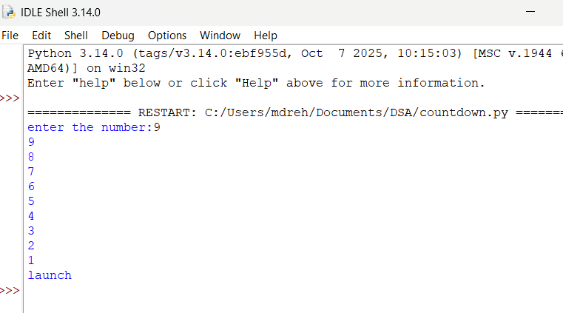
Explanation
Condition 1: Positive Input (n > 0)
- The function checks whether n == 0.
- Since n is positive, the condition is False.
- It executes:
  - print(n) → prints the current value of n.
  - countdown(n-1) → calls the same function again with n-1.
- This process continues until n becomes 0.
- When n == 0, the condition becomes True.
- It prints launch.
- The return statement stops that function call.
- Then the recursive calls return one by one.
- Since there is no value returned by the function, it returns None.
Condition 2: Zero Input (n == 0)
- The function checks if n == 0.
- The condition is immediately True.
- It prints launch.
- The return statement stops the function.
- No recursive call takes place.
- The function returns None.
Condition 3: Negative Input (n < 0)
- The condition n == 0 is False.
- It prints the negative value.
- Then it calls itself with n-1, making the value even more negative.
- Therefore, it will never reach 0.
- The recursion continues indefinitely.
- Eventually, Python raises a RecursionError because the maximum recursion depth is exceeded
s.no | Error obtained | Rectification
1 | Negative input in countdown | Add a condition to handle negative numbers before recursion.

1B. Aim: Banks calculate the growth of an investment using compound interest. The formula requires calculating powers, which can be implemented recursively. Write a recursive program to calculate p(n) where p=principal growth, n= no. of years.
Code:
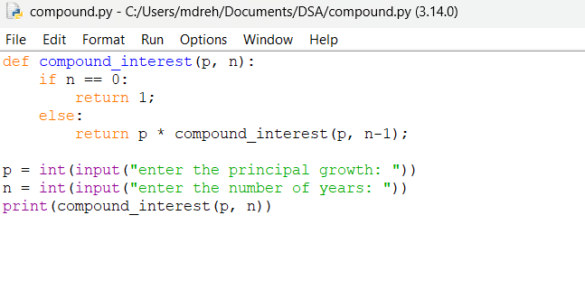
Output:
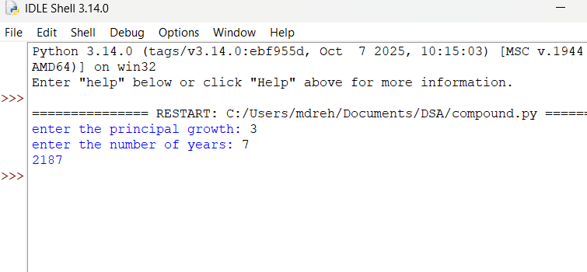
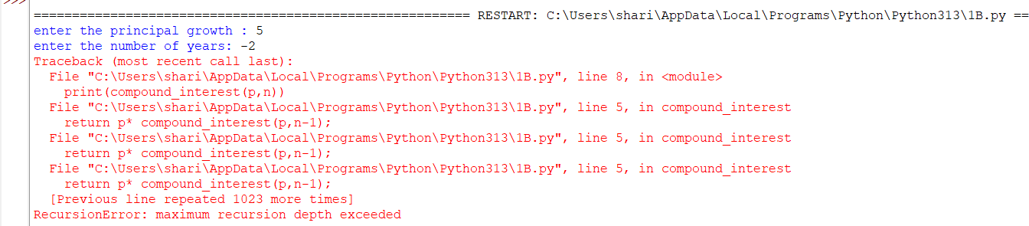
Explanation
Condition 1: n > 0
- The function compound_interest(p, n) is called with the principal amount p and number of years n.
- The function checks whether n == 0.
- Since n is greater than 0, the condition is False.
- It executes the else block.
- It calculates:
  - p * compound_interest(p, n-1)
- The function calls itself recursively with n-1.
- This process continues until n becomes 0.
- Each recursive call multiplies p one more time.
- Therefore, the function calculates pⁿ.
Condition 2: n == 0
- When n becomes 0, the condition n == 0 becomes True.
- The function returns 1.
- This 1 acts as the base case for the multiplication.
- The recursive calls then return one by one.
- Each returned value is multiplied by p.
- Finally, the result is printed using print(compound_interest(p,n))
Error table:
s.no | Error obtained | rectification
1 | Wrong indentation | Maintain proper indentation.

1C. AIM . An Hr department stores employee IDs in a list .Develop a recursive program to search for a given employee ID write a recursive function to search for an employee ID in a list.
Code:
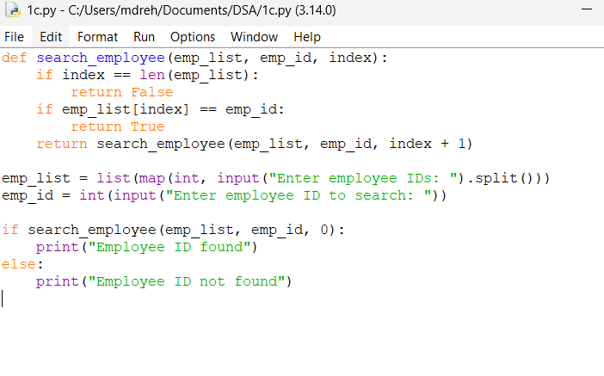
Output:
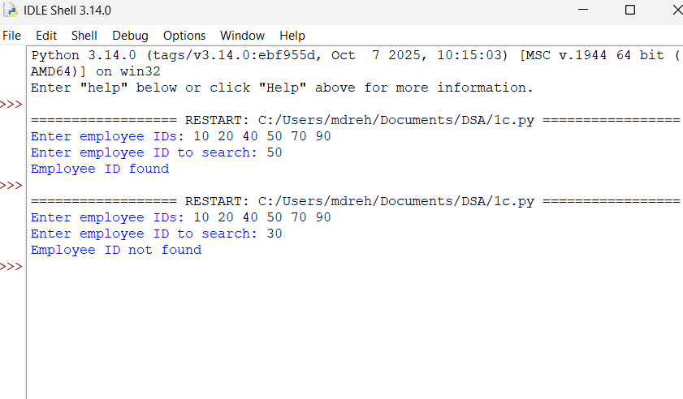

Explanation
Condition 1: index == len(emp_list)
- The function checks whether index has reached the length of the employee list.
- If index == len(emp_list), it means we have checked all employee IDs.
- The employee ID was not found.
- The function returns False.
- No further recursion takes place.
Condition 2: emp_list[index] == emp_id
- The function checks whether the current employee ID is equal to the ID we are searching for.
- If both IDs are equal, the condition becomes True.
- The function returns True.
- The recursion stops because the employee ID has been found.
Condition 3: Employee ID does not match
- If the current employee ID is not equal to emp_id, the condition is False.
- The function calls itself recursively with:
  - index + 1
- This moves to the next employee ID in the list.
- The process continues until:
  - The employee ID is found, or
  - The entire list is checked.
Error table:
s.no | Error obtained | Rectification
1 | Missing return statement | Add the required return statement

1D. AIM. In a logistics company , the no . of possible ways to arrange in different parcels is calculated using the factorial formula (n!). Develop a recursive program to calculate the factorial of a given number.
Code:
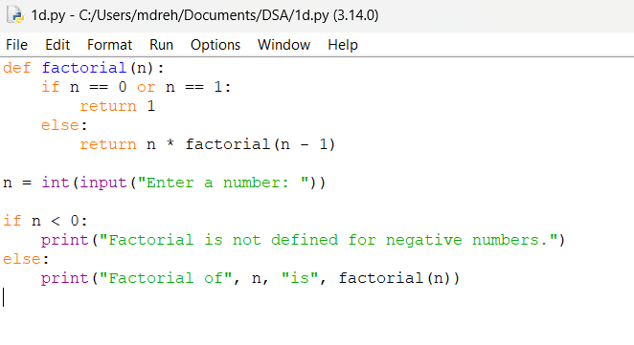
Output:
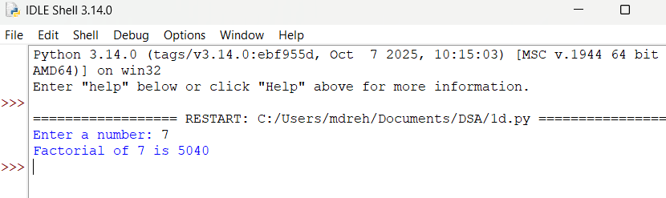
Explanation
Condition 1: Negative Input (n < 0)
- The program first checks whether n < 0.
- If n is negative, the condition is True.
- Factorial is not defined for negative numbers.
- It prints:
Factorial is not defined for negative numbers.
- The factorial() function is not called.
Condition 2: Base Case (n == 0 or n == 1)
- Inside the factorial() function, it checks:
n == 0 or n == 1
- If n is 0 or 1, the condition is True.
- The function returns 1.
- This is the base case of the recursion.
- It stops further recursive calls.
Condition 3: n > 1
- If n is greater than 1, the condition n == 0 or n == 1 is False.
- The else block is executed.
- It returns:
n * factorial(n - 1)
- The function calls itself with n - 1.
- This continues until n becomes 1.
- Then the returned values are multiplied together
Error table:
s.no | Error obtained | Rectification
1 | Wrong recursive value | Updated the recursive value correctly

1E. AIM. Write a recursive program to print the first n terms of the fibonacci series
Code:
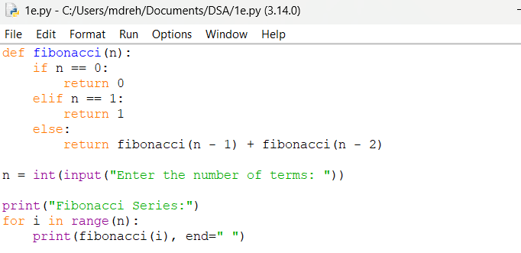
Output:
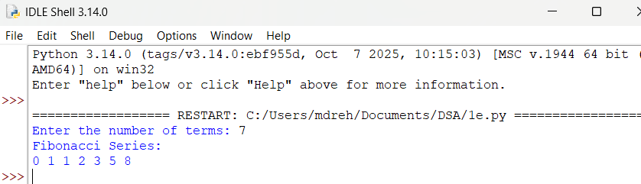
Explanation
Condition 1: n == 0
- The function checks whether n == 0.
- If the condition is True, the function returns 0.
- This is the first base case.
- No further recursive call takes place.
Condition 2: n == 1
- If n is not 0, the function checks whether n == 1.
- If the condition is True, the function returns 1.
- This is the second base case.
- No further recursive call takes place
Condition 3: n > 1
- If n is neither 0 nor 1, both conditions are False.
- The else block is executed.
- The function calls itself two times:
  - fibonacci(n - 1)
  - fibonacci(n - 2)
- The two returned values are added together.
- This process continues until the base cases n == 0 and n == 1 are reached.
Error table:
s.no | Error obtained | Rectification
1 | Incorrect Fibonacci recursion | Use fibonacci(n-1) + fibonacci(n-2).

Week-2
2a. AIM: Write a python program to perform linear search on the give input.
Code:
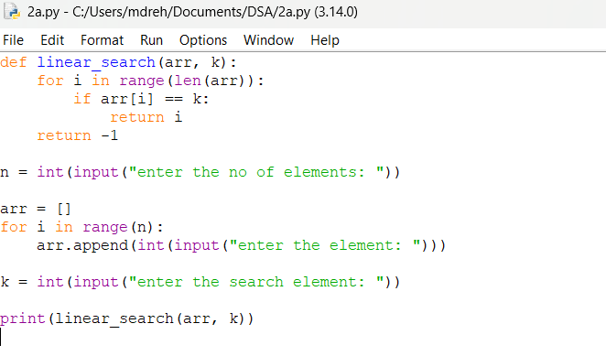
Output:
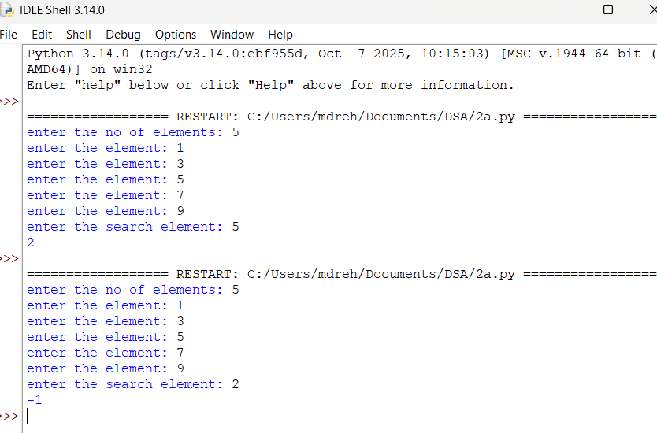
Explanation
Condition 1: Element is Found (arr[i] == k)
- The function linear_search(arr, k) receives the array arr and the search element k.
- The for loop starts from the first element of the array.
- It checks each element one by one using:
arr[i] == k
- If the current element is equal to k, the condition becomes True.
- The function immediately returns the index i.
- Since the function returns the index, the loop stops immediately.
- The remaining elements are not checked.
Condition 2: Element is Not Found
- The loop checks every element in the array.
- If none of the elements is equal to k, the if condition is always False.
- After the loop finishes, the statement return -1 is executed.
- -1 indicates that the search element is not present in the array.
Error table:
s.no | Error obtained | Rectification
1 | Wrong loop range | Use range(n) to process exactly n elements.

2b. AIM: Write a python program to perform binary search on the given. Verify by taking sorted array as an input.
Code:
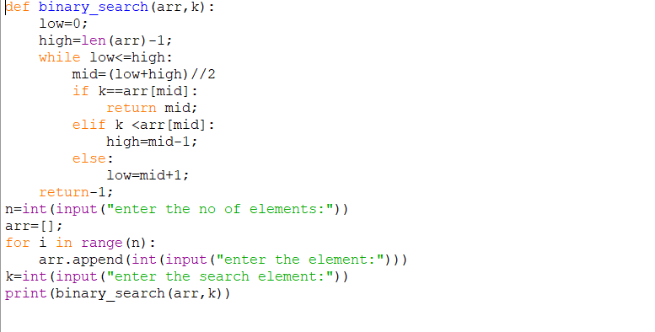
Output:
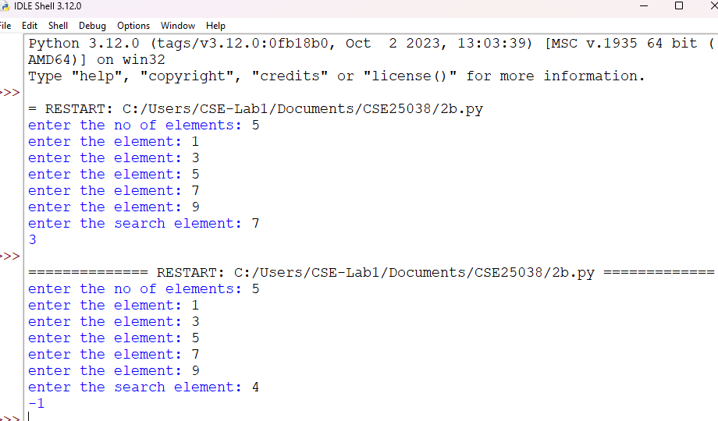
Explanation
Condition 1: k == arr[mid] — Element Found
- The function binary_search(arr, k) receives the array and the search element.
- low is initialized to 0, which represents the first index.
- high is initialized to len(arr)-1, which represents the last index.
- The while loop runs as long as low <= high.
- mid is calculated using:
mid = (low + high) // 2
- The middle element is compared with the search element k.
- If k == arr[mid], the element is found.
- The function returns the index mid and stops searching.
Condition 2: k < arr[mid] — Search Left Half
- If k is smaller than the middle element, the condition is True.
- This means the search element can only be present in the left half.
- Therefore:
high = mid - 1
- The right half is eliminated.
- The process continues with the remaining left half
Condition 3: k > arr[mid] — Search Right Half
- If k is greater than the middle element, the elif condition is False.
- The else block is executed.
- This means the search element can only be present in the right half.
- Therefore:
low = mid + 1
- The left half is eliminated.
- The process continues with the remaining right half.
Condition 4: low > high — Element Not Found
- The while loop continues until low <= high becomes False.
- When low > high, there are no elements left to search.
- This means the search element is not present in the array.
- The function returns -1.
Error table:
s.no | Error obtained | Rectification
 | Wrong index in binary search | Use high = mid - 1 for the left half and low = mid + 1 for the right half.
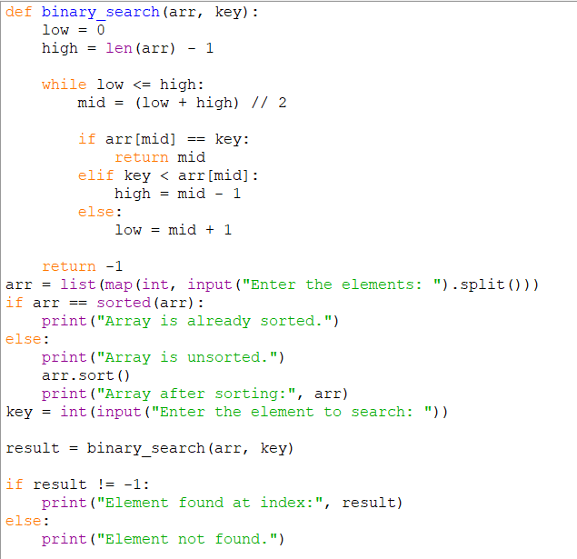
Output:

Explanation
Condition 1: arr[mid] == key — Element Found
- The function first calculates the middle index using mid = (low + high) // 2.
- It compares the middle element arr[mid] with the search element key.
- If arr[mid] == key, the condition is True.
- The element is found.
- The function returns the index mid.
- The search stops.
Condition 2: key < arr[mid] — Search Left Half
- If key is smaller than arr[mid], the condition is True.
- This means the required element may be present in the left half.
- The right half is ignored.
- high is changed to mid - 1.
- The search continues in the left half.
Condition 3: key > arr[mid] — Search Right Half
- If key is greater than arr[mid], the previous conditions are False.
- The element may be present in the right half.
- The left half is ignored.
- low is changed to mid + 1.
- The search continues in the right half.
Condition 4: low > high — Element Not Found
- The while low <= high loop continues until there are elements left to search.
- When low > high, the loop stops.
- This means the element is not present in the array.
- The function returns -1.
- The program prints "Element not found."
Condition 5: Array is Already Sorted
- The program checks whether the given array is already sorted.
- It uses:
arr == sorted(arr)
- If the condition is True, it prints:
"Array is already sorted."
- The array is directly used for binary search.
Condition 6: Array is Unsorted
- If arr == sorted(arr) is False, the array is unsorted.
- The program prints:
"Array is unsorted."
- It then uses arr.sort() to sort the array.
- The sorted array is displayed.
- Binary search is then performed on the sorted array.

Error table:
s.no | Error obtained | Rectification
1 | Binary search on unsorted array | sort the array first using arr.sort() or provide a sorted array.

TIME COMPLEXITY AND SPACE COMPLEXITY
PROGRAM | TIME COMPLEXITY | SPACE COMPLEXITY | REASON
1. Linear Search | O(n) | O(1) | The program checks the elements one by one. In the worst case, all n elements are checked, and no extra data structure is used.
2. Binary Search – Sorted Array | O(log n) | O(log n) | The search range is divided into half at every recursive call. The recursion stack stores the recursive calls.
3. Binary Search – Unsorted Array | O(n log n) | O(log n) | The array is first sorted using sort(), which takes O(n log n) time, followed by binary search in O(log n). The recursive search uses O(log n) stack space.

LAB 3

AIM 1.a) Write a python program to sort the elements using bubble sort technique. Take an input from the user.
Program:
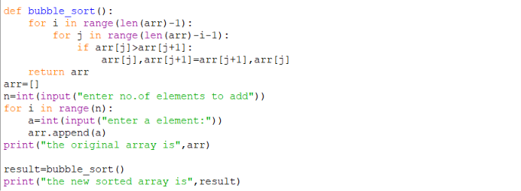
Output:
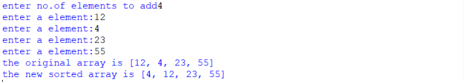
Explanation:
This program sorts the elements using Bubble Sort. It repeatedly compares adjacent elements and swaps them if they are in the wrong order. After each pass, the largest unsorted element moves to its correct position at the end of the list.
Error Table:
ERROR | CAUSE | SOLUTION
Index Error | Incorrect loop range or index access. | Check the loop limits and valid list indices.
Value Error | A non-integer value is entered when an integer is required. | Enter valid integer values.
Logic Error | The swap condition or loop condition is incorrect. | Check the comparison and swapping statements.
AIM 1.b) Write a python program to sort the elements using Insertion sort technique. Take an input from the user.
Program:
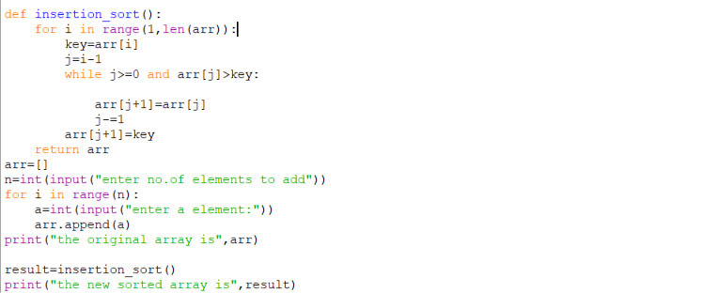
Output:
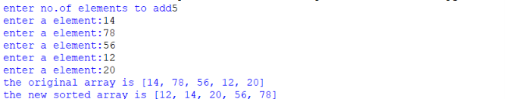
Explanation:
This program sorts the elements using Insertion Sort. It takes one element at a time and inserts it into its correct position among the already sorted elements on its left. The process continues until all elements are sorted.
Error Table:
ERROR | CAUSE | SOLUTION
Index Error | Incorrect access to the list while shifting elements. | Use valid indices and check the loop range.
Value Error | Invalid non-integer input is entered. | Enter valid integer values.
Logic Error | Elements are not shifted or inserted in the correct position. | Check the comparison and insertion logic.
AIM 1.c) Write a python program to sort the elements using selection sort technique. Take an input from the user.
Program:
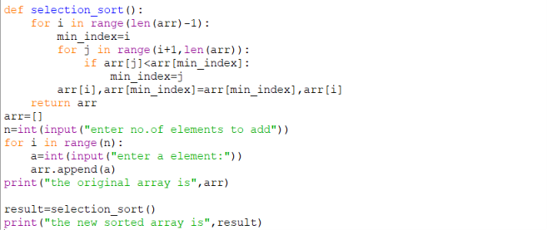
Output:
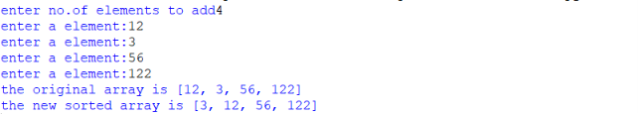
Explanation:
This program sorts the elements using Selection Sort. In each pass, it finds the smallest element from the unsorted part of the list and places it at the beginning of that part. This continues until the complete list is sorted.
Error Table:
ERROR | CAUSE | SOLUTION
Index Error | Incorrect loop range while finding the minimum element. | Check the loop boundaries and list indices.
Value Error | Invalid non-integer input is entered. | Enter valid integer values.
Logic Error | The minimum element or swap position is selected incorrectly. | Check the minimum-element comparison and swap.
AIM 1.d) Write a python program to sort the elements using Quick sort technique. Take an input from the user.
Program:
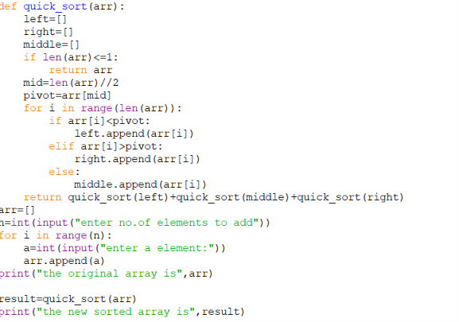
Output:
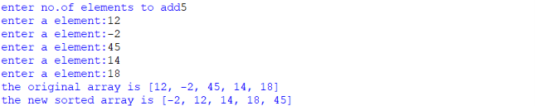
Explanation:
This program sorts the elements using Quick Sort. It selects a pivot element and partitions the list so that smaller elements are placed on one side and larger elements on the other side. The same process is then applied recursively to the two parts.
Error Table:
ERROR | CAUSE | SOLUTION
Recursion Error | Recursive calls do not reach the base condition. | Ensure the partition reduces the problem size.
Index Error | Incorrect low, high, or partition boundaries. | Check the partition indices and recursive ranges.
Logic Error | Pivot partitioning is performed incorrectly. | Check the pivot comparison and partition logic.
AIM 1.e) Write a python program to sort the elements using Merge sort technique. Take an input from the user.
Program:
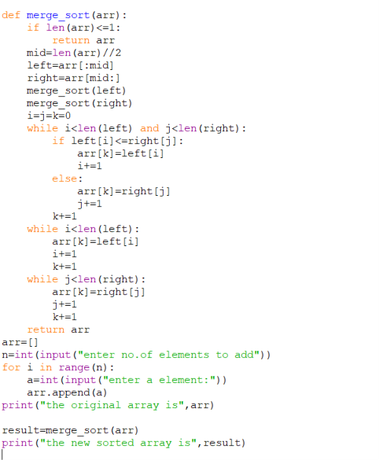
Output:
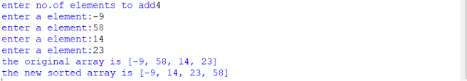
Explanation:
This program sorts the elements using Merge Sort. It divides the list into smaller halves until single elements remain, then merges the smaller sorted parts back together in the correct order to obtain the final sorted list.
Error Table:
ERROR | CAUSE | SOLUTION
Index Error | Incorrect indices are used while splitting or merging. | Check the sub-list boundaries and indices.
Value Error | Invalid non-integer input is entered. | Enter valid integer values.
Logic Error | The two sorted parts are not merged correctly. | Check the comparison and merging steps.

TIME COMPLEXITY AND SPACE COMPLEXITY
PROGRAM | BEST TIME | AVERAGE TIME | WORST TIME | SPACE COMPLEXITY | REASON
1. Bubble Sort | O(n) | O(n²) | O(n²) | O(1) | Adjacent elements are compared repeatedly. With an optimized version, an already sorted list can finish in one pass.
2. Insertion Sort | O(n) | O(n²) | O(n²) | O(1) | Each element is inserted into its correct position. It is fast when the input is already or nearly sorted.
3. Selection Sort | O(n²) | O(n²) | O(n²) | O(1) | The minimum element is searched in the remaining unsorted part during every pass.
4. Quick Sort | O(n log n) | O(n log n) | O(n²) | O(log n) | The array is partitioned around a pivot. Balanced partitions give O(n log n), while highly unbalanced partitions give O(n²).
5. Merge Sort | O(n log n) | O(n log n) | O(n log n) | O(n) | The list is divided into halves and the sorted halves are merged. Extra space is required for merging.

LAB -4
Aim 4.a:Write a program to implement a single linked list which would perform the below operations, by taking an input from the user.
a)create a linked list
b)insert at beginning
c)insert at end
d)insert at a specified index
e)delete by value
f)delete 1st node
g)delete last node
h)count no.of nodes
i)display or traverse
j)search for a number
k)exit
Program:

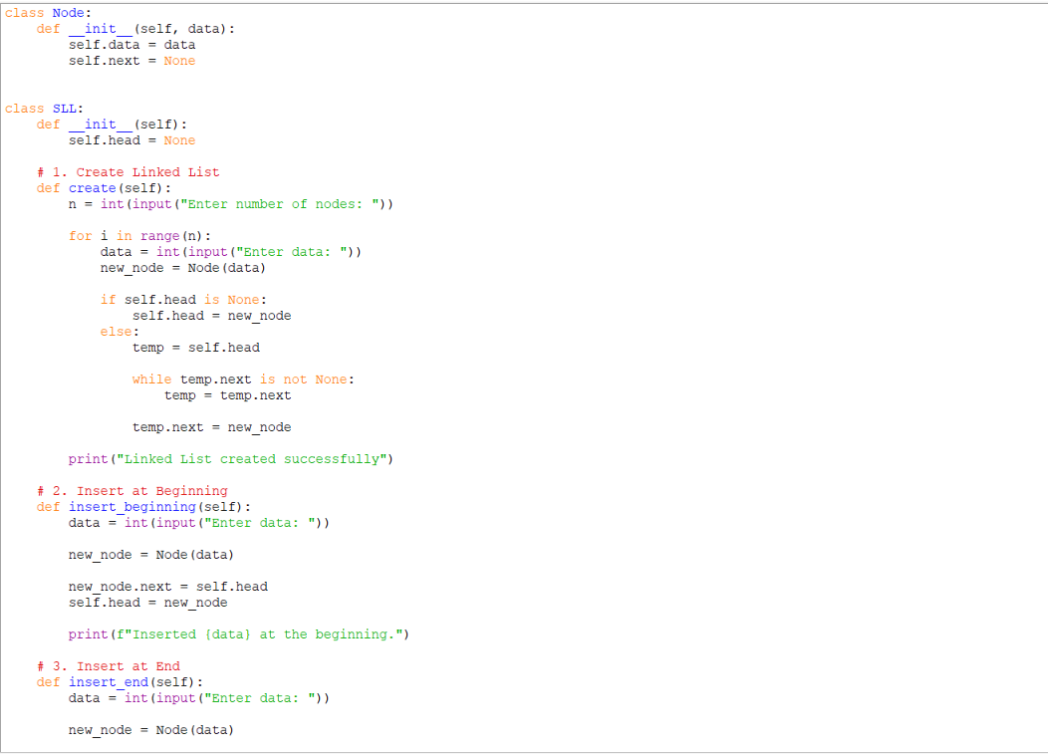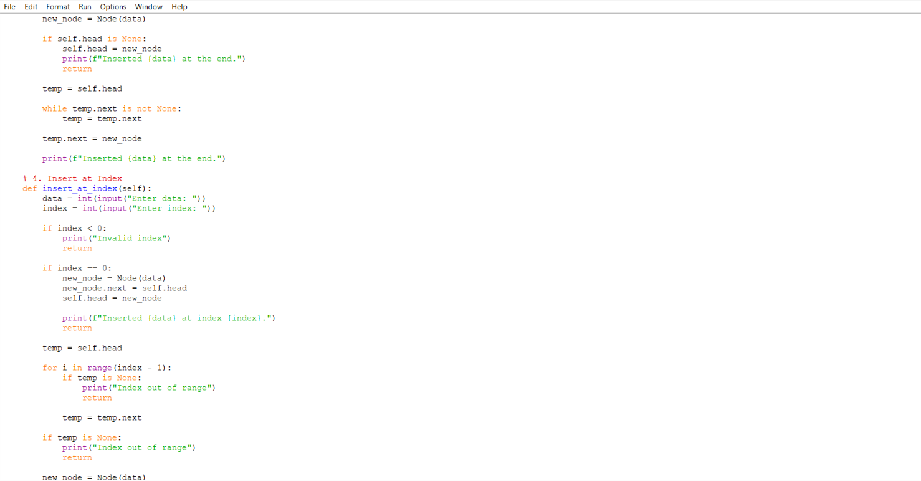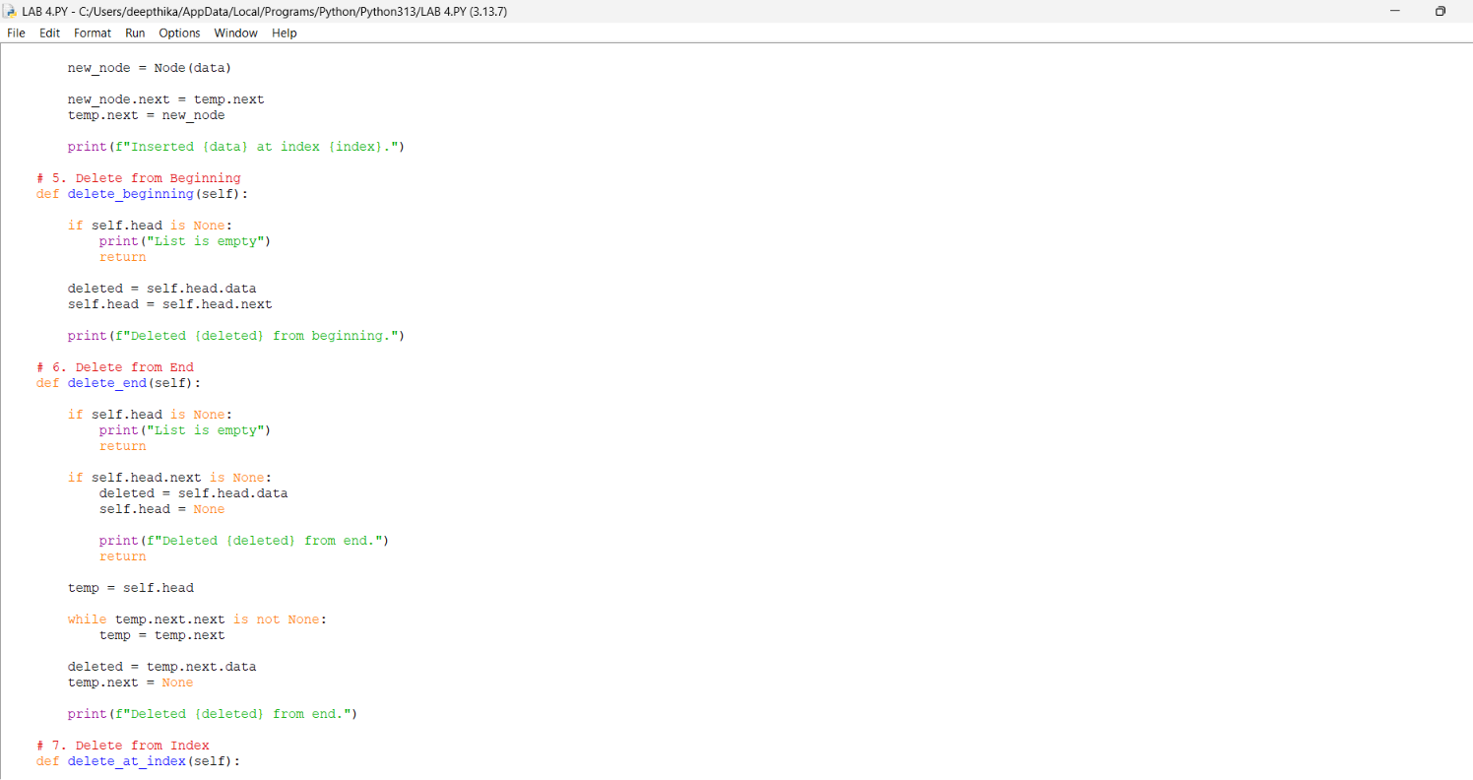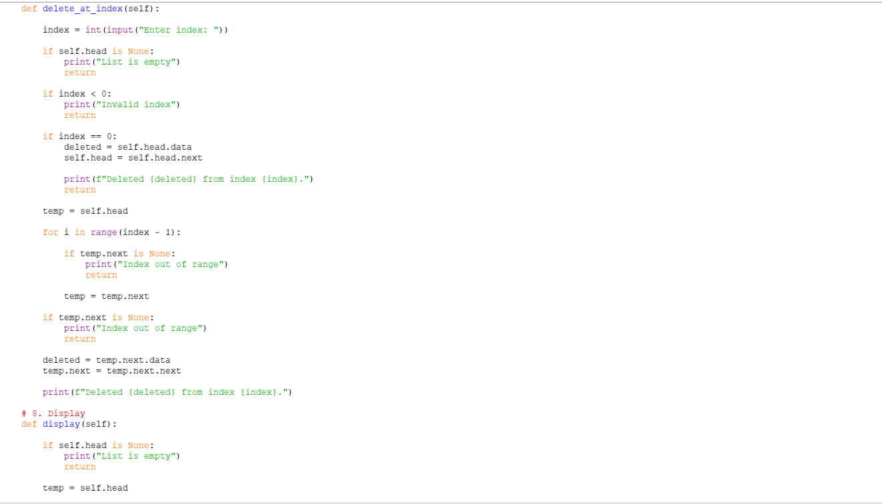
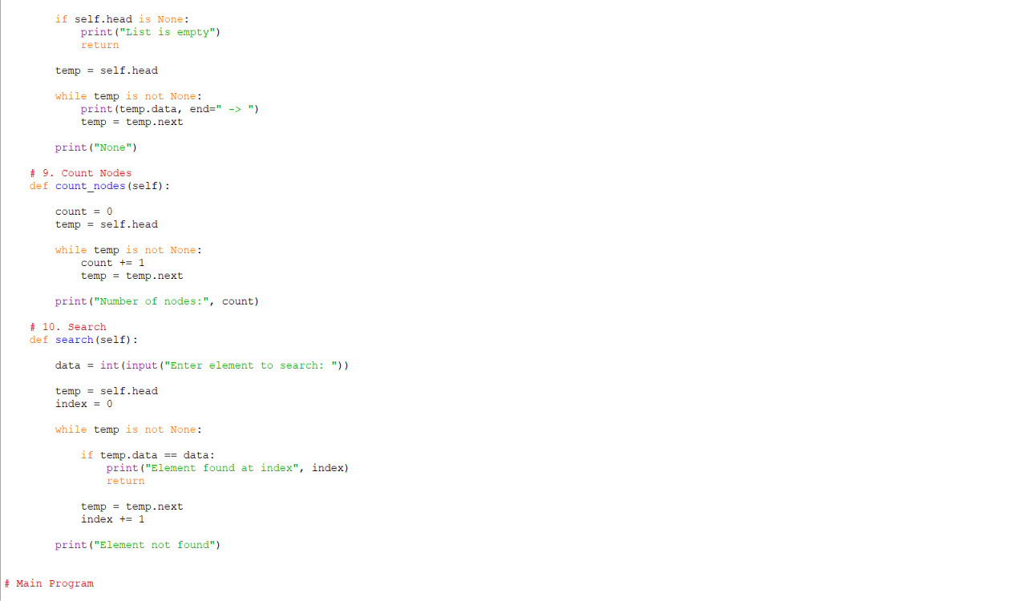
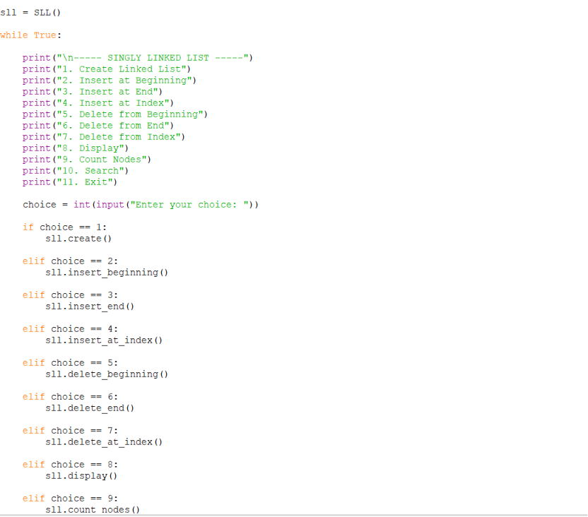

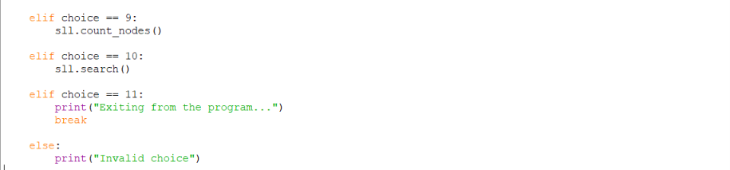
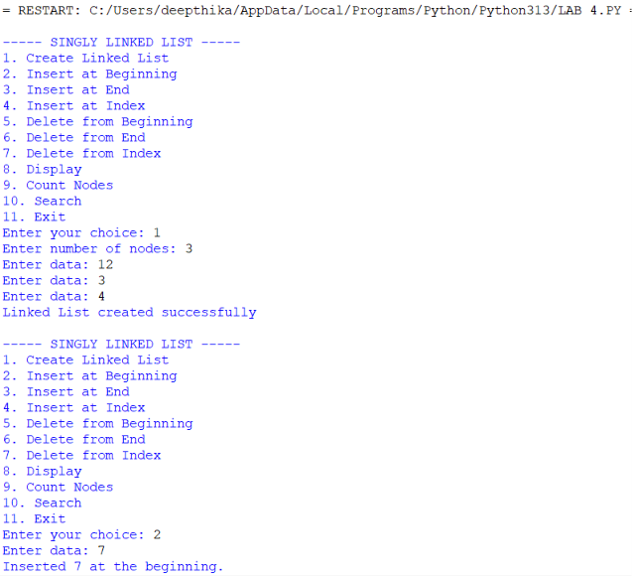
Output:

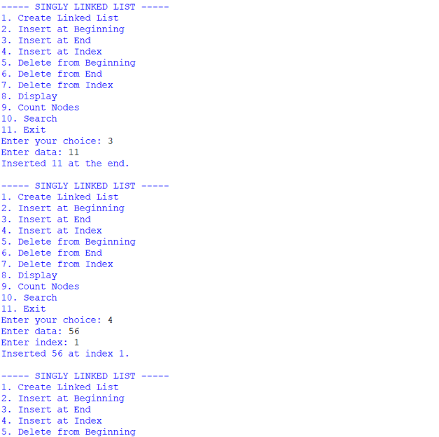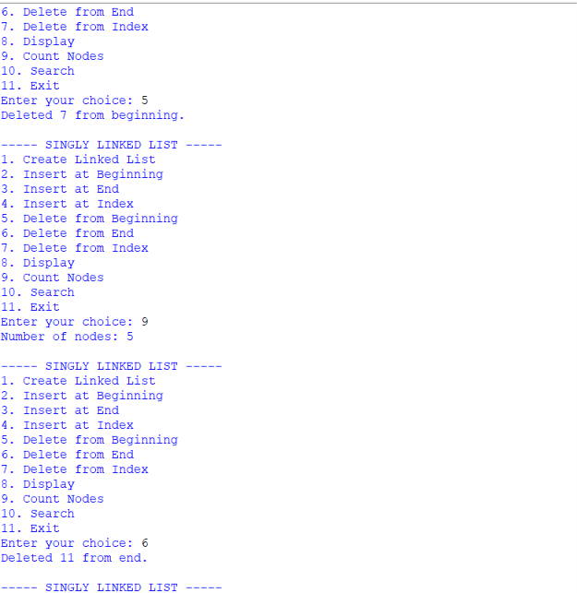
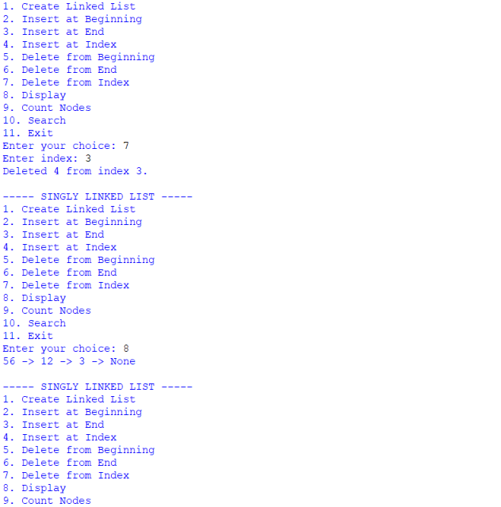
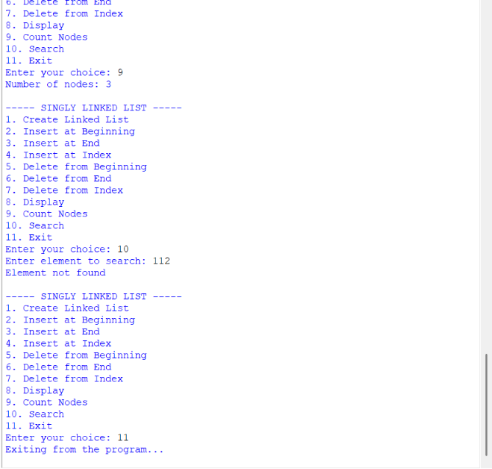
Explanation:
A Singly Linked List (SLL) is a linear data structure in which each node contains two parts: data and a next pointer. The data part stores the value, while the next part stores the address/reference of the next node. The head pointer points to the first node of the linked list. The last node points to None, indicating the end of the list.
The program implements the following operations:
- Create Linked List: Creates a linked list by taking the number of nodes and their data from the user. Each new node is connected to the previous node.
- Insert at Beginning: Creates a new node and makes it the first node by changing the head pointer.
- Insert at End: Traverses the list until the last node and connects the new node to it.
- Insert at Index: Inserts a new node at a specified position by adjusting the links between nodes.
- Delete from Beginning: Removes the first node by moving the head pointer to the next node.
- Delete from End: Traverses to the second-last node and changes its next pointer to None.
- Delete from Index: Removes a node from a specified position by changing the next pointer of the previous node.
- Display: Traverses the complete linked list and displays each node's data.
- Search: Traverses the list and checks each node to find the required element. It also displays its index if found.
- Count Nodes: Traverses the list using a temporary pointer and increments count for every node until None is reached.
- Exit: Terminates the program.
The program uses a menu-driven approach, allowing the user to select and perform different linked-list operations repeatedly.
ERROR TABLE :
PROGRAM | ERROR / PROBLEM | CAUSE | CORRECTION
1. Create Linked List | List is not created properly | head or next links are not initialized correctly | Initialize head = None and connect each new node using next.
2. Insert at Beginning | New node is not inserted at the beginning | head is not updated correctly | Set new_node.next = self.head and then self.head = new_node.
3. Insert at End | New node is not added at the end | Traversal or next assignment is incorrect | Traverse until temp.next is None and set temp.next = new_node.
4. Insert at Index | Node is inserted at the wrong position | Incorrect index traversal | Traverse up to index - 1 and adjust the next links.
5. Delete from Beginning | First node is not deleted | head is not moved to the next node | Set self.head = self.head.next.
6. Delete from End | Last node is not deleted | Second-last node is not identified correctly | Traverse until temp.next.next is None and set temp.next = None.
7. Delete from Index | Wrong node is deleted | Incorrect index or link modification | Traverse to index - 1 and update temp.next = temp.next.next.
8. Display | List elements are not displayed completely | temp is not updated during traversal | Use temp = temp.next until temp is None.
9. Search | Element is not found correctly | List is not traversed completely | Compare each node and update temp = temp.next.
10. Count Nodes | Incorrect number of nodes is displayed | Last node is skipped during counting | Use while temp is not None and increment count for every node.
Aim 4.b:Write a program to implement a double linked list which would perform the below operations, by taking an input from the user.
a)create a linked list
b)insert at beginning
c)insert at end
d)insert at a specified index
e)delete by value
f)delete 1st node
g)delete last node
h)count no.of nodes
i)display or traverse
j)search for a number
k)exit
Program:
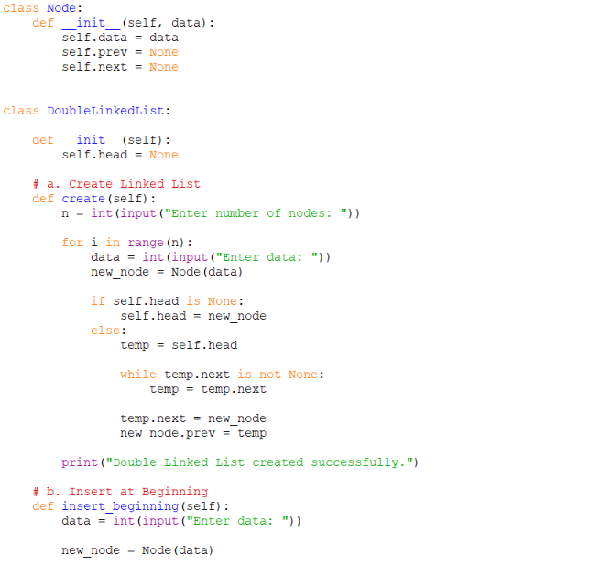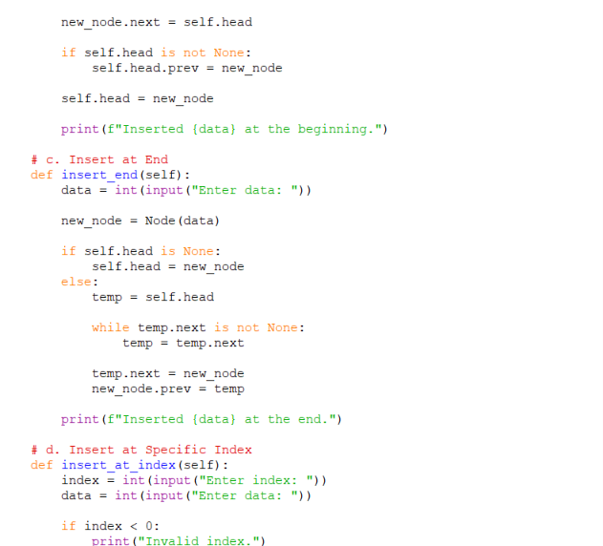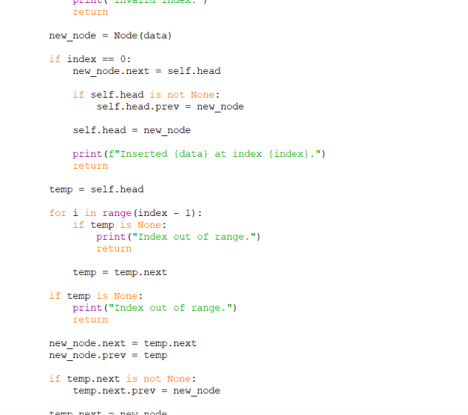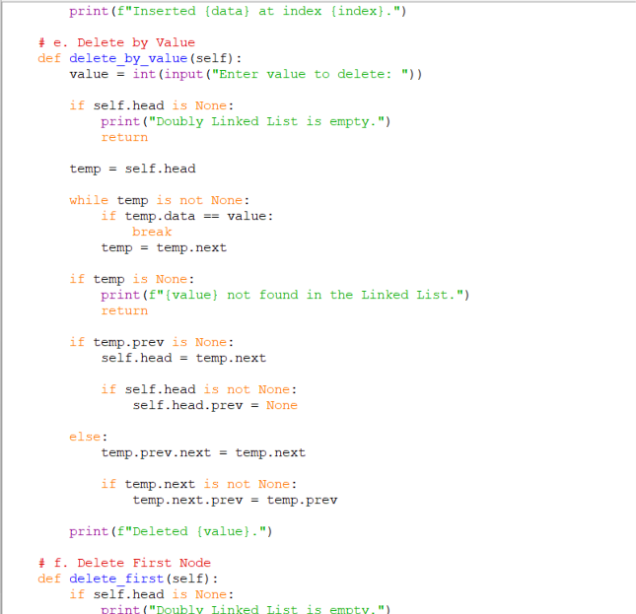
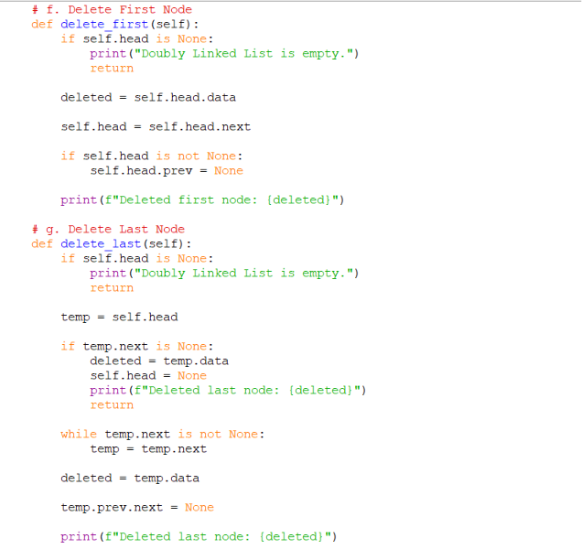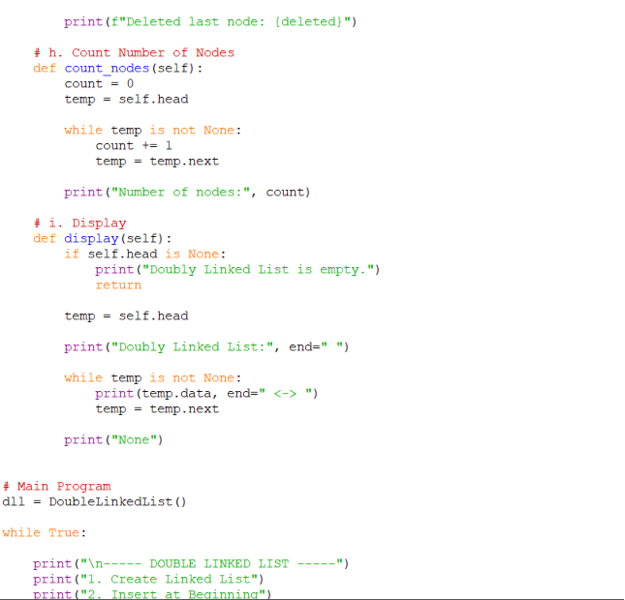
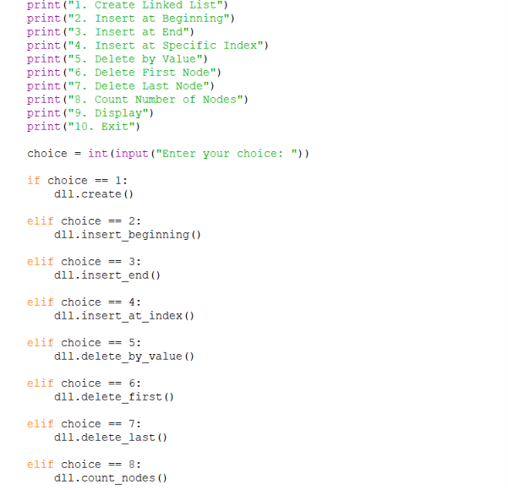
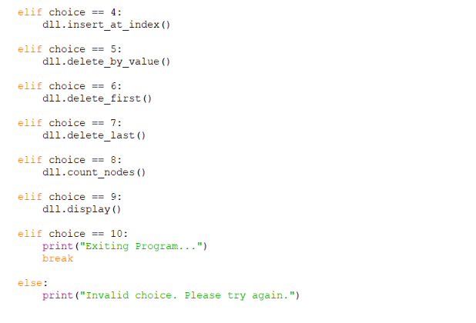
Output:
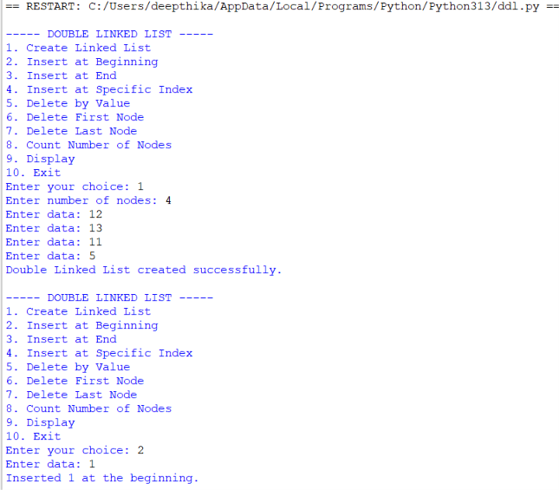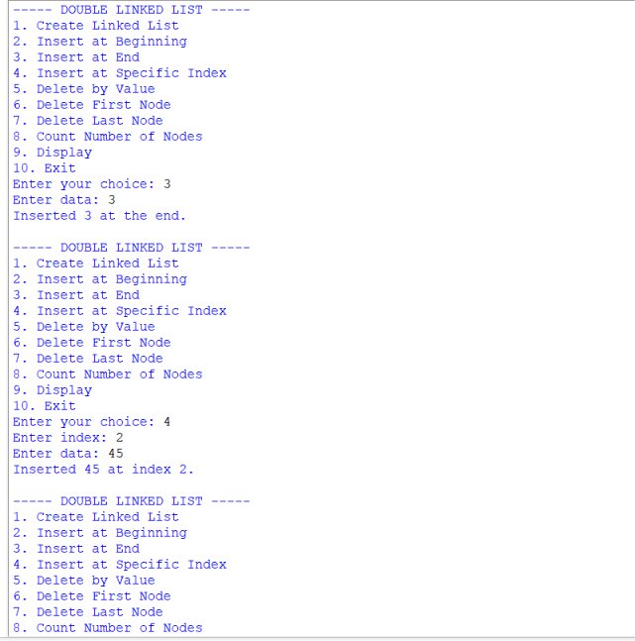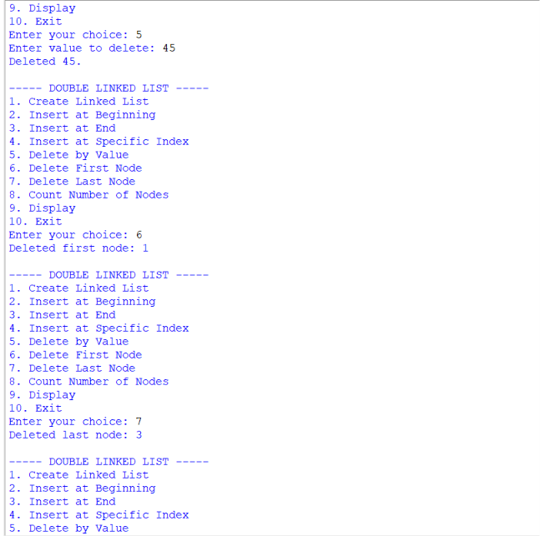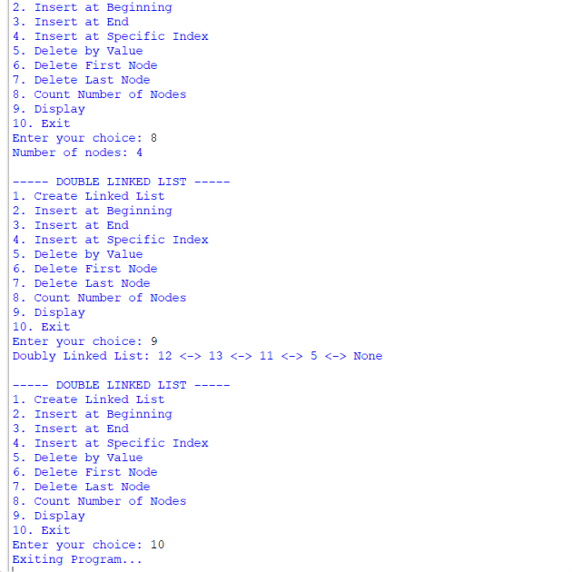
ERROR TABLE:
PROGRAM | ERROR / PROBLEM | CAUSE | CORRECTION
1. Create Linked List | List is not created properly | prev or next links are not initialized correctly | Initialize head = None and connect each node using both prev and next.
2. Insert at Beginning | New node is not inserted at the beginning | head or prev link is not updated correctly | Set new_node.next = self.head, update the old head.prev, and update self.head.
3. Insert at End | New node is not added at the end | Traversal or next/prev assignment is incorrect | Traverse to the last node and update both next and prev links.
4. Insert at Index | Node is inserted at the wrong position | Incorrect index traversal | Traverse to index - 1 and adjust the prev and next links.
5. Delete by Value | Required node is not deleted | Value is not found or links are not updated | Find the node and reconnect the previous and next nodes correctly.
6. Delete from Beginning | First node is not deleted | head is not moved or prev is not reset | Move head to the next node and set the new head.prev = None.
7. Delete from End | Last node is not deleted | Last or previous node is not identified correctly | Traverse to the last node and set the previous node.next = None.
8. Display | List elements are not displayed completely | Traversal pointer is not updated | Use temp = temp.next until temp is None.
9. Search | Element is not found correctly | List is not traversed completely | Compare each node and update temp = temp.next.
10. Count Nodes | Incorrect number of nodes is displayed | A node is skipped during traversal | Traverse until temp is None and increment count for every node.
Explanation:
A Doubly Linked List (DLL) is a linear data structure in which each node contains three parts: data, a next pointer, and a previous pointer. The next pointer stores the reference to the next node, while the previous pointer stores the reference to the previous node. The head points to the first node, and the previous pointer of the first node is None. The program performs creation, insertion at the beginning, insertion at the end, insertion at a specified index, deletion, display, search, and counting operations. The menu-driven approach allows the user to repeatedly select the required operation.

Aim 4.c:Write a program to implement a circular linked list which would perform the below operations, by taking an input from the user.
a)create a linked list
b)insert at beginning
c)insert at end
d)insert at a specified index
e)delete by value
f)delete 1st node
g)delete last node
h)count no.of nodes
i)display or traverse
j)search for a number
k)exit
program:
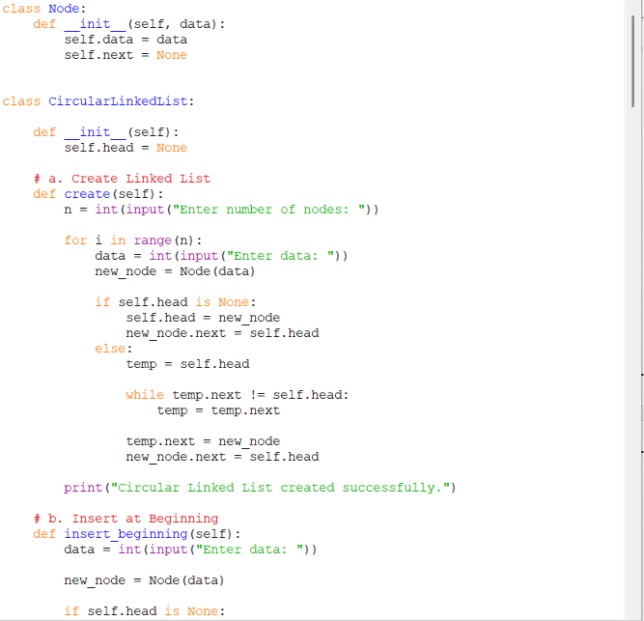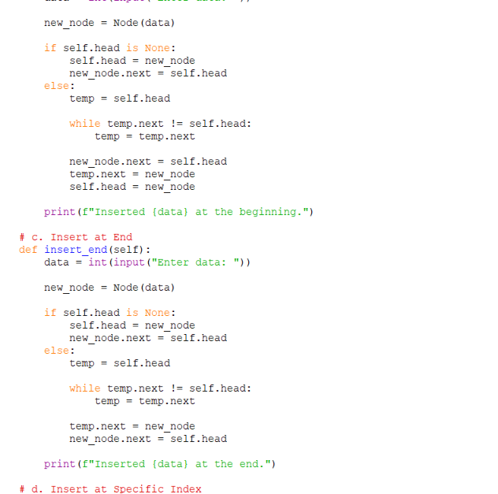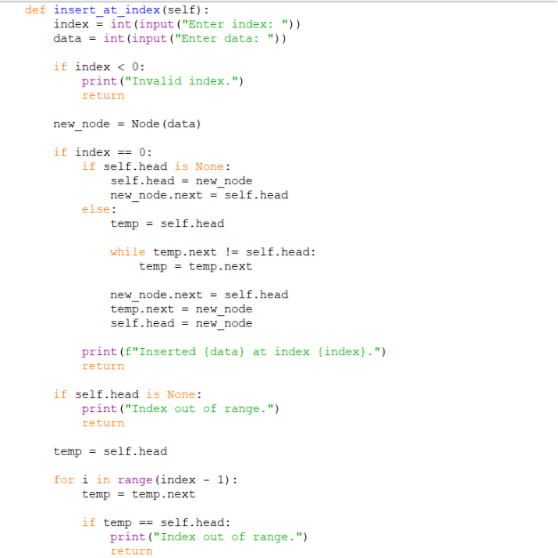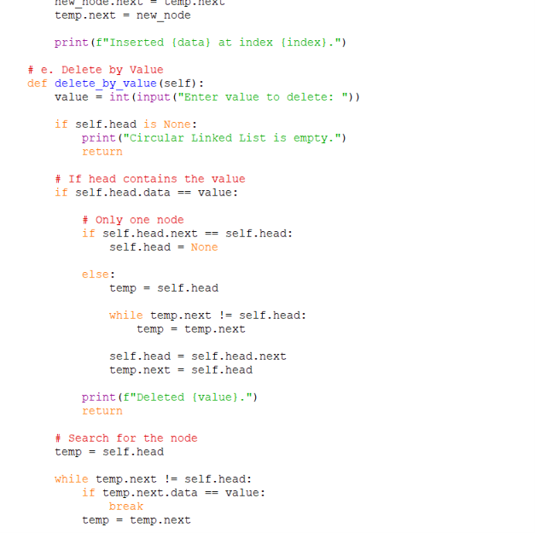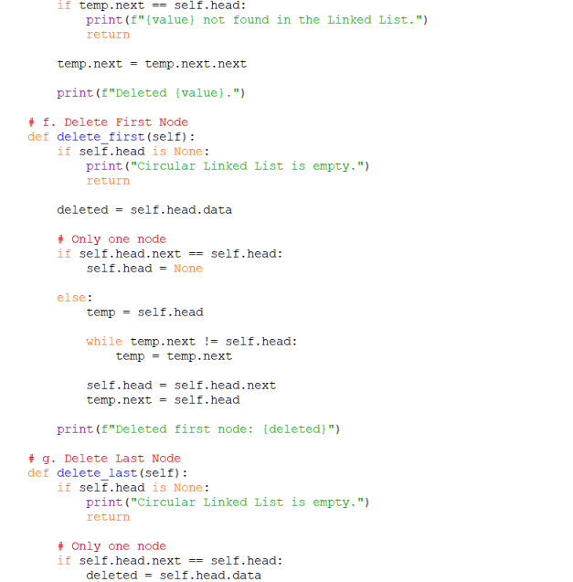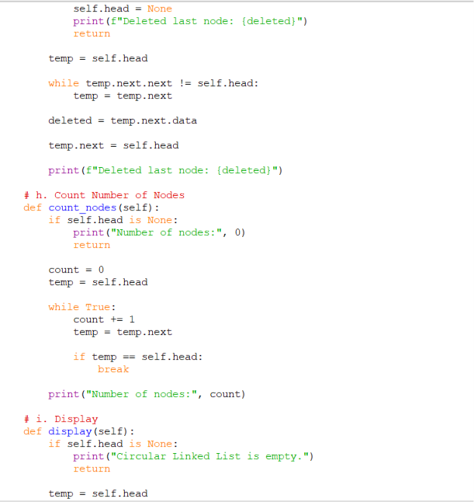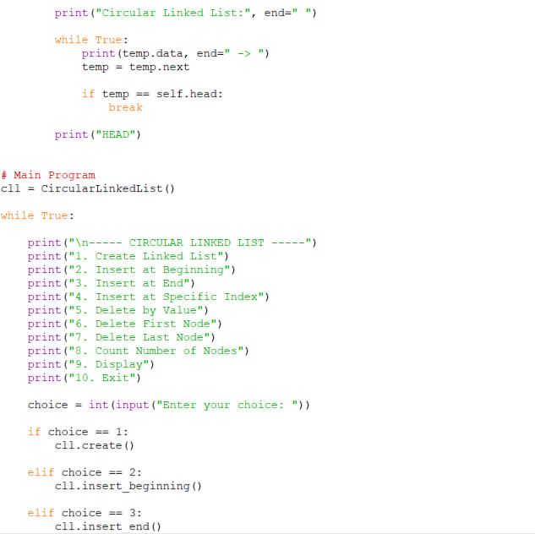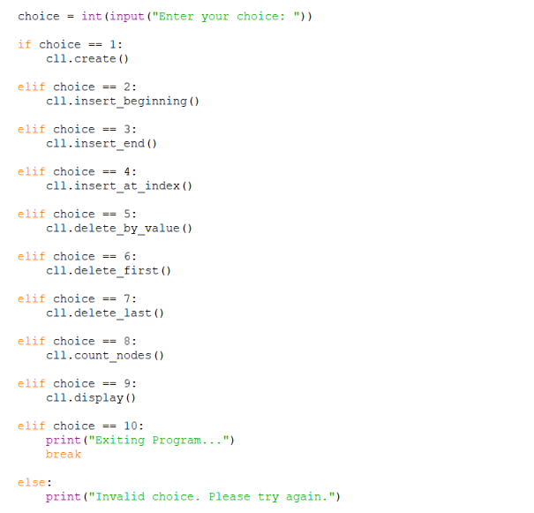
output:
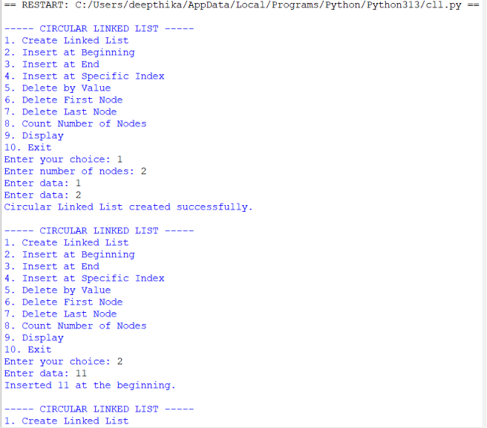
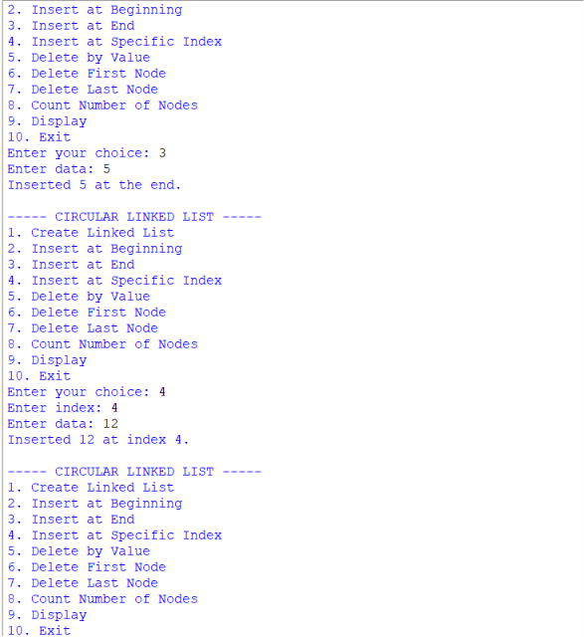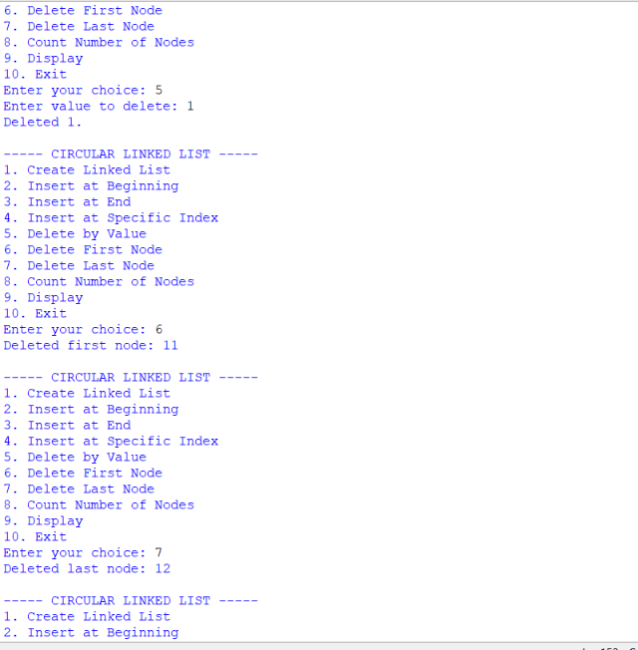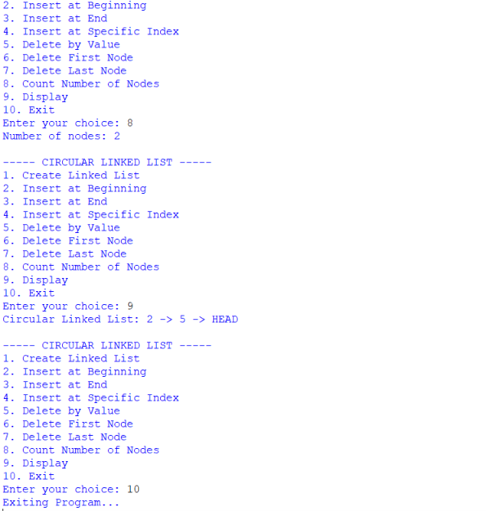

TIME COMPLEXITY AND SPACE COMPLEXITY
PROGRAM | BEST TIME | AVERAGE TIME | WORST TIME | SPACE COMPLEXITY | REASON
1. Create Linked List | O(n) | O(n²) | O(n²) | O(n) | Each node is created and connected. Traversing to the end for every insertion makes creation O(n²).
2. Insert at Beginning | O(1) | O(1) | O(1) | O(1) | A new node is directly connected to the current head.
3. Insert at End | O(n) | O(n) | O(n) | O(1) | The list is traversed until the last node before insertion.
4. Insert at Index | O(1) | O(n) | O(n) | O(1) | The list may need to be traversed up to the required index.
5. Delete from Beginning | O(1) | O(1) | O(1) | O(1) | Only the head pointer is moved to the next node.
6. Delete from End | O(n) | O(n) | O(n) | O(1) | The list must be traversed to find the second-last node.
7. Delete from Index | O(1) | O(n) | O(n) | O(1) | Traversal may be required to reach the node before the specified index.
8. Display | O(n) | O(n) | O(n) | O(1) | Every node is visited once to display its data.
9. Search | O(1) | O(n) | O(n) | O(1) | The element may be found at the first node or require checking the entire list.
10. Count Nodes | O(n) | O(n) | O(n) | O(1) | Every node is visited once to calculate the total count.

LAB 5
5. AIM: Write a python program to implement a stack using an Array, Linked list. Implement the stack operations such as push, pop, peak and also display the stack elements.
PROGRAM:

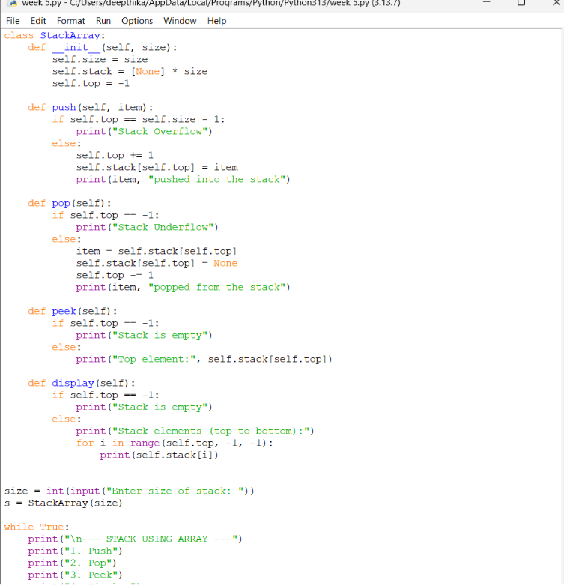

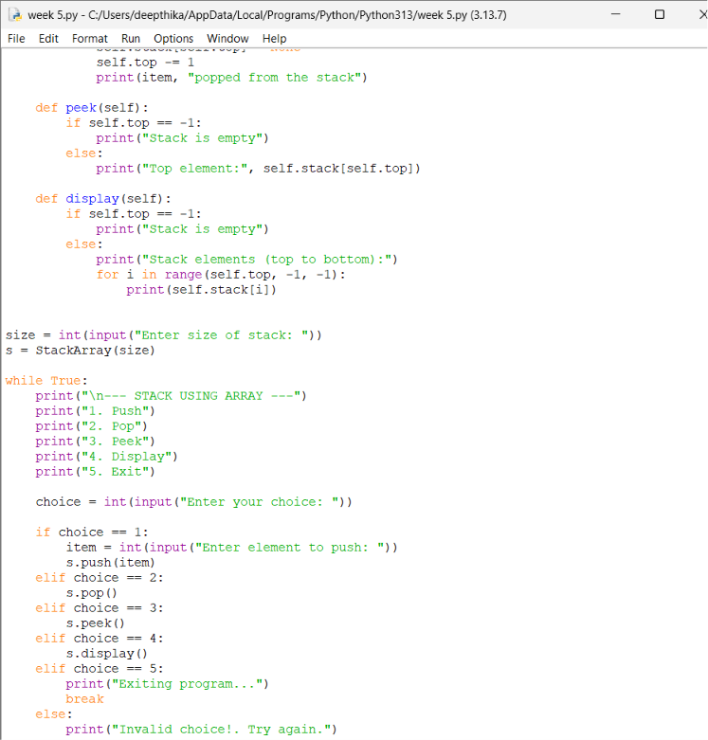
Output:

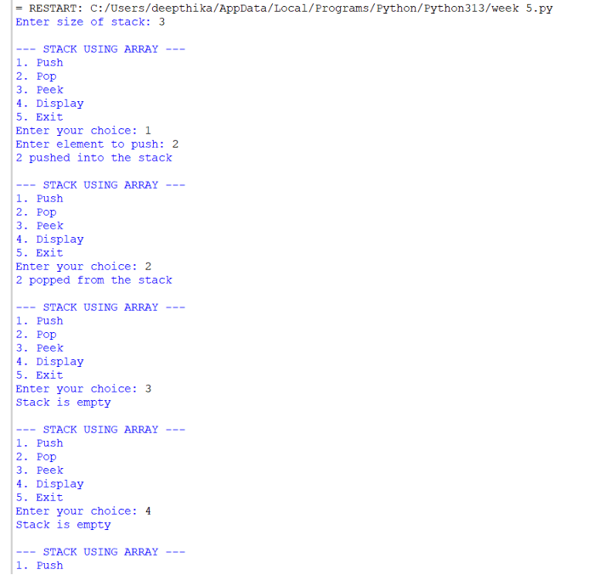
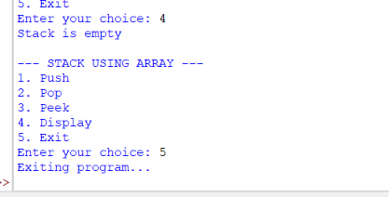
Negative case:

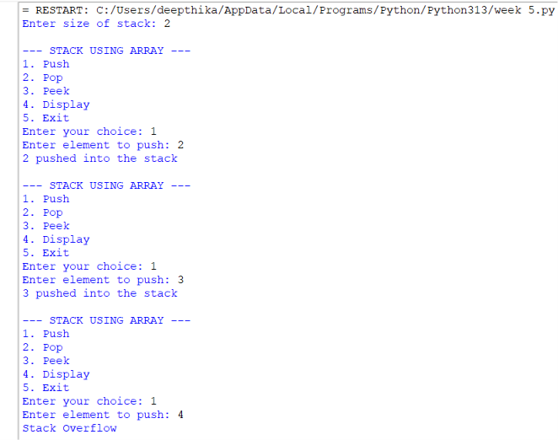
Stack Using Linked List:
\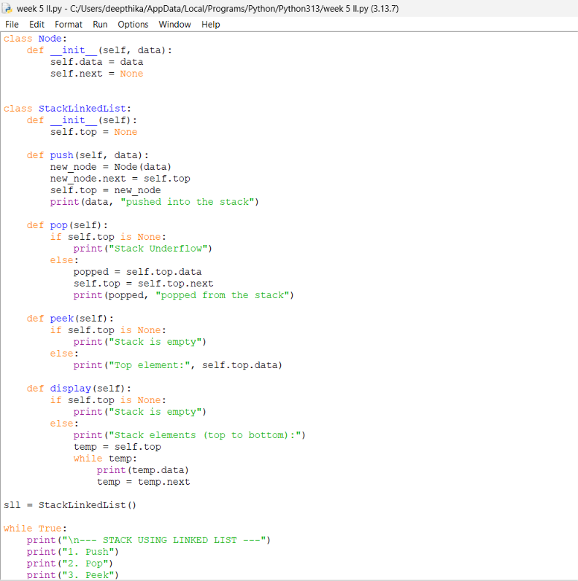
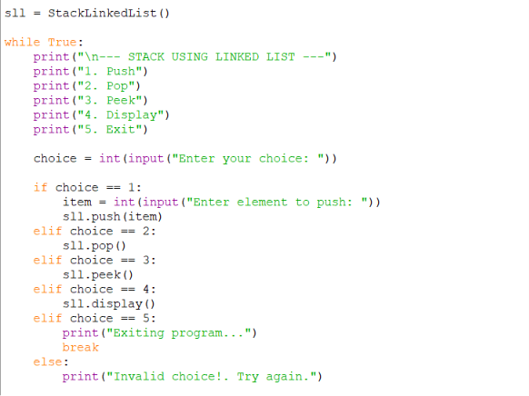
Output:

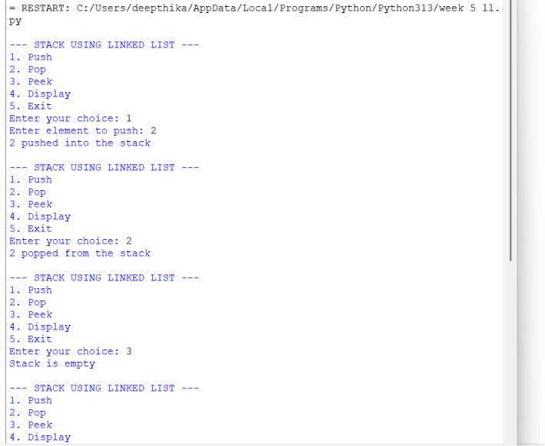
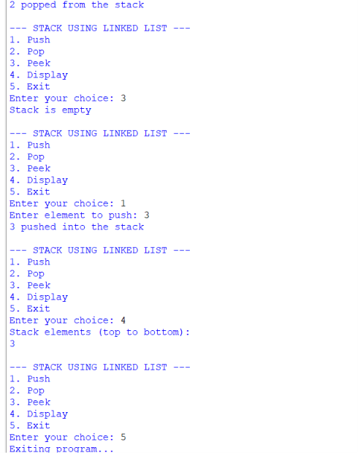
Negative case:

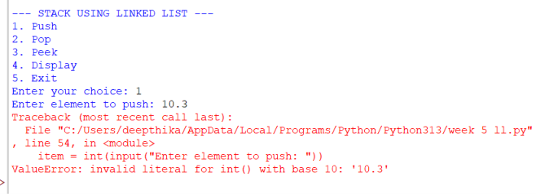

EXPLANATION:
Stack Using Array
Structure:
- Uses a Python list (self.stack) to store elements.
- self.top keeps track of the index of the last pushed element.
- self.size defines the maximum capacity.
Operations:
- Push
  - Check if top == size - 1 → Overflow.
  - Otherwise, increment top and insert the element at that position.
- Pop
  - Check if top == -1 → Underflow (empty stack).
  - Otherwise, remove the element at top, decrement top.
- Peek
  - Shows the element at top without removing it.
- Display
  - Prints elements from top down to 0 (top to bottom order)
Stack Using Linked List
Structure:
- Each element is a Node with:
  - data (value)
  - next (pointer to the next node).
- self.top points to the most recently pushed node.
Operations:
- Push
  - Create a new node.
  - Link its next to the current top.
  - Update top to this new node.
- Pop
  - If top is None → Underflow.
  - Otherwise, remove the node at top and update top to top.next.
- Peek
  - Shows the data at top.
- Display
  - Traverse from top downwards, printing each node’s data.
ERROR TABLE:
S.NO | Error Obtained | Rectification
1. | def _init_(self, size): | Python expects two underscores before and after init.
2. | Display on empty stack. | Add condition: if self.top is None: → print  "Stack is empty".
3. |  | Add a check: if self.top == self.size - 1: → print "Stack Overflow".
  Stack Overflow
  when pushing beyond the defined size
4. | Stack Underflow  when popping from empty stack | Add a check: if self.top is None: → print "Stack Underflow".
5. | Syntax error | Later it was rectified in the for loop of display section.

Lab 6
Aim : Write a python program to implement a queue using an Array, Linked list, circular queue. Implement the queue operations such as enqueue, dequeue, peak and also display the queue elements.
Program: Circular Queue

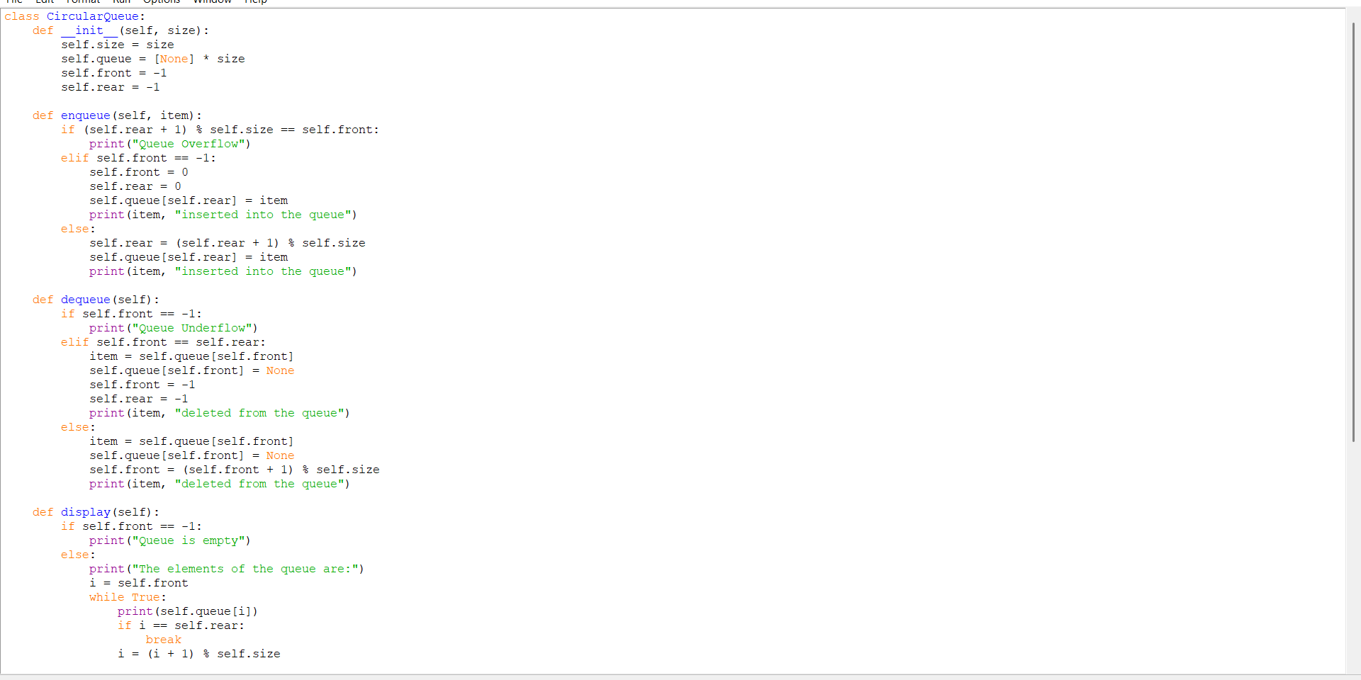
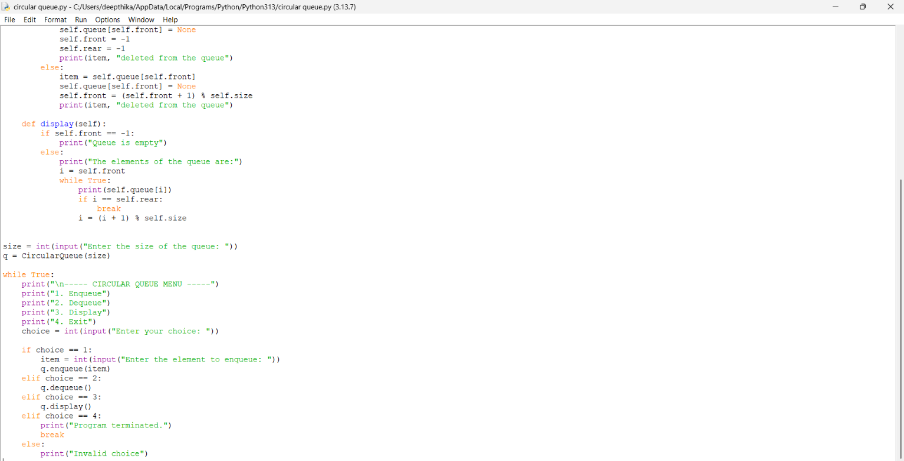
Output:
Positive case:

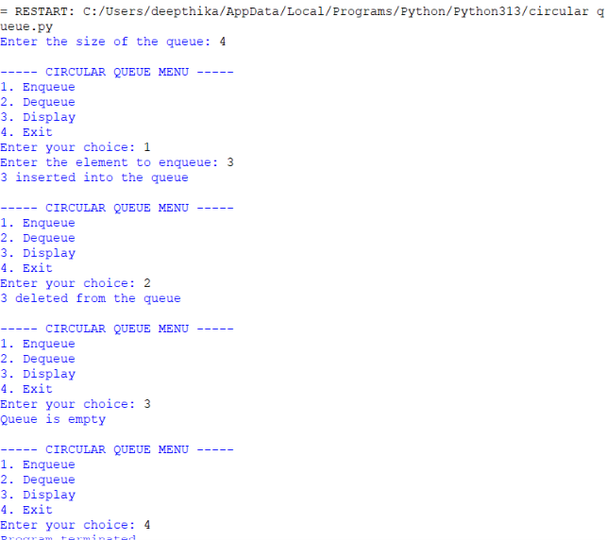
Negative case:

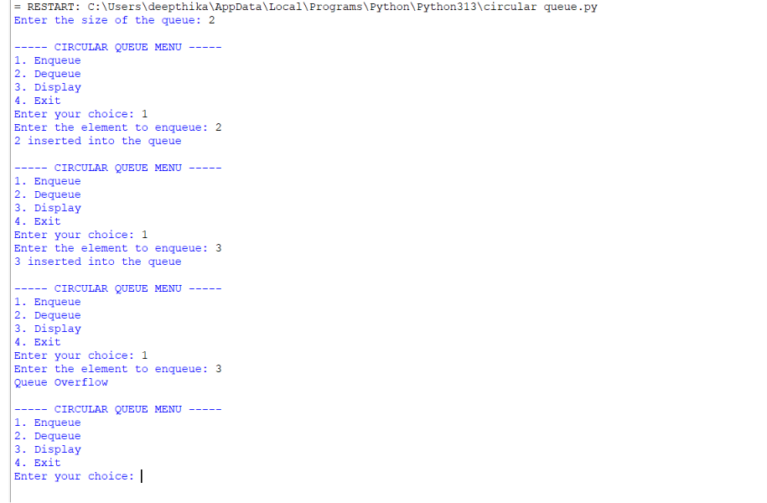
Explanation:
Queue Using Array
Structure:
- Uses a Python list self.queue to store elements.
- self.front keeps track of the first element in the queue.
- self.rear keeps track of the last element in the queue.
- self.size defines the maximum capacity of the queue.
- Initially:
  - front = -1
  - rear = -1
Operations:
1. Enqueue
- Check if rear == size - 1 → Overflow (queue is full).
- If the queue is empty, set front = 0.
- Increment rear.
- Insert the element at rear.
2. Dequeue
- Check if front == -1 or front > rear → Underflow (queue is empty).
- Remove the element at front.
- Increment front.
- If the queue becomes empty, reset front and rear to -1.
3. Peek
- Shows the element at front without removing it.
- If the queue is empty → Underflow/empty message.
4. Display
- Prints elements from front to rear.
- Elements are displayed in front-to-rear order.
Important Points:
- Queue follows FIFO (First In, First Out).
- Insertion takes place at the rear.
- Deletion takes place at the front.
- Overflow → queue is full.
- Underflow → queue is empty.
A0B
Error table:
ERROR TABLE:
S.NO | Error Obtained | Rectification
1. | Display on empty circular queue. | Add condition: if self.front == -1: → print "Queue is empty".
2. | Circular Queue Overflow | Add a check: if (self.rear + 1) % self.size == self.front: → print "Circular Queue Overflow".
3. | Circular Queue Underflow | Add a check: if self.front == -1: → print "Circular Queue Underflow".
4. | rear does not wrap around to the beginning of the array. | Update using: self.rear = (self.rear + 1) % self.size.

Program:Array

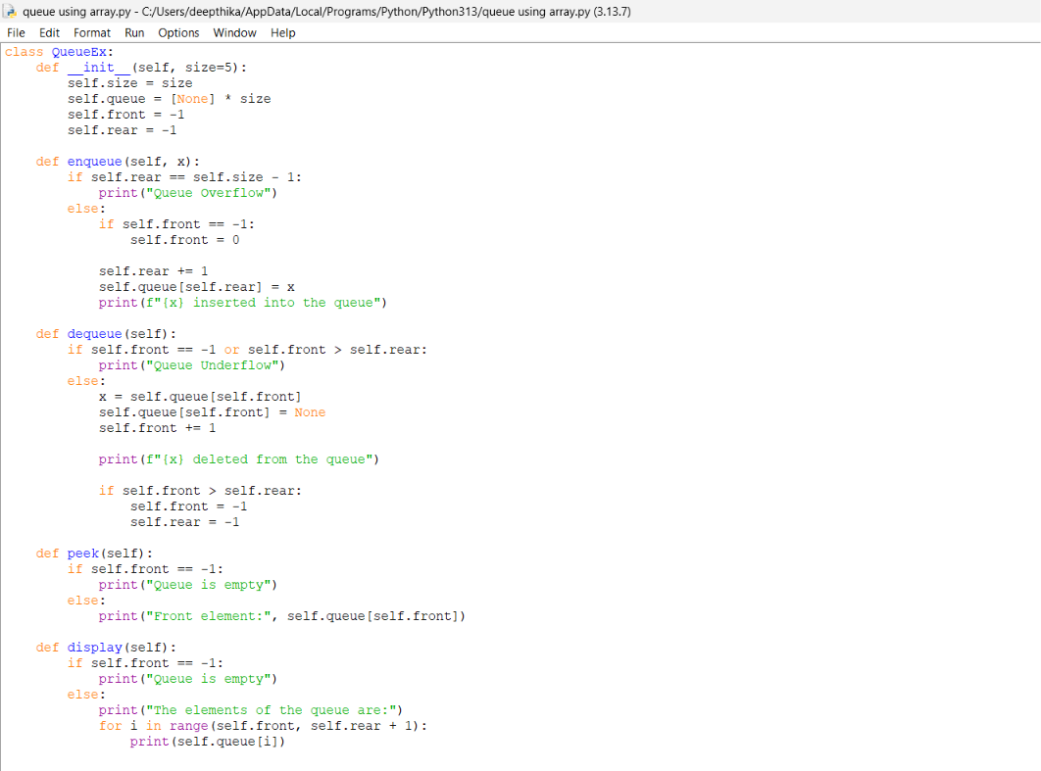
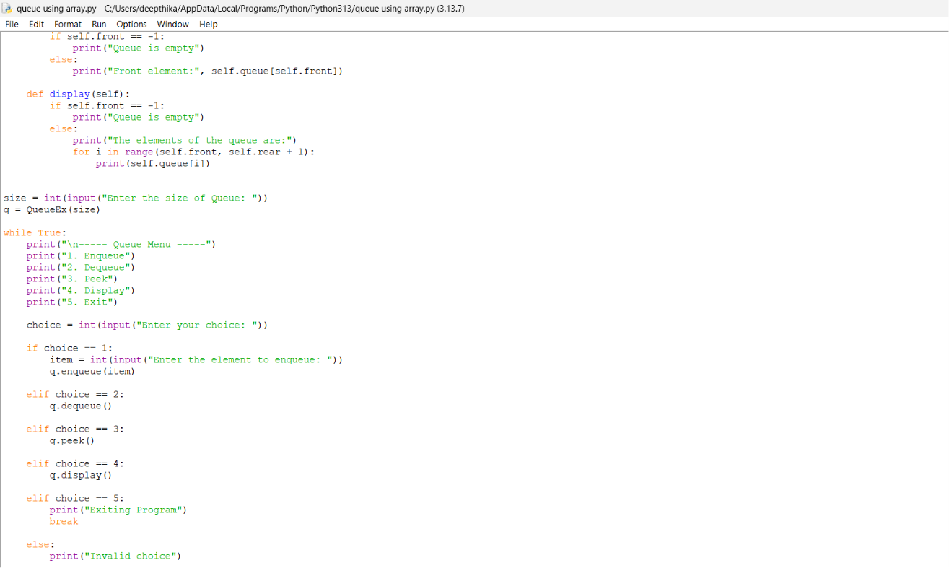
Output:
Positive case:

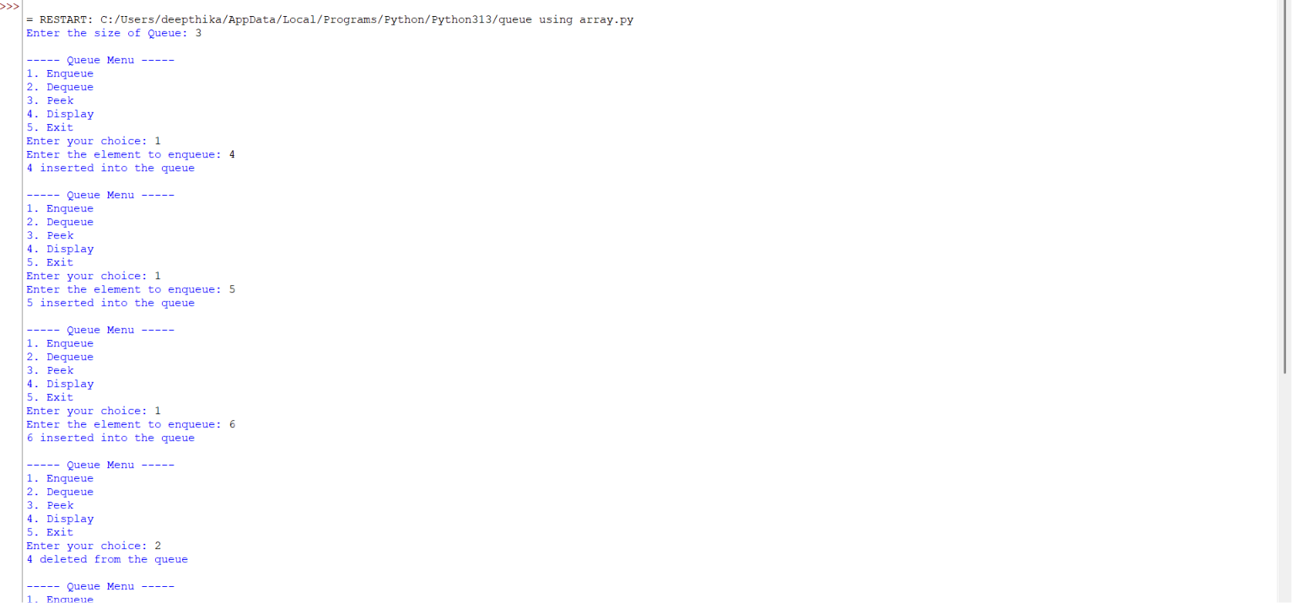
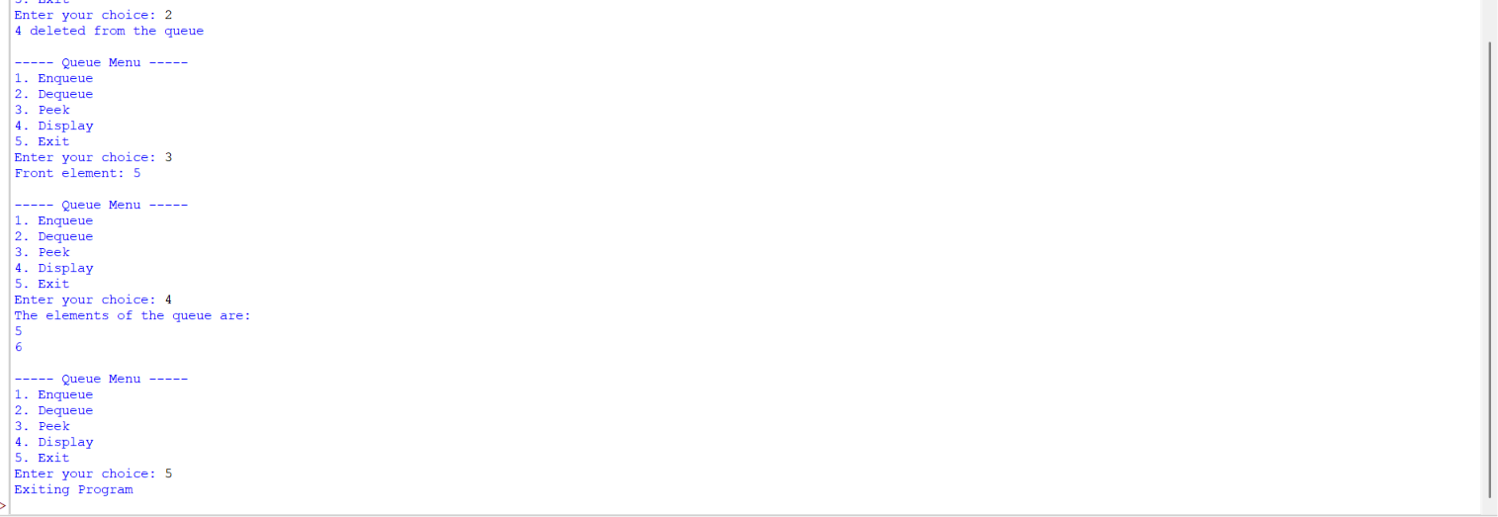
Negative case:

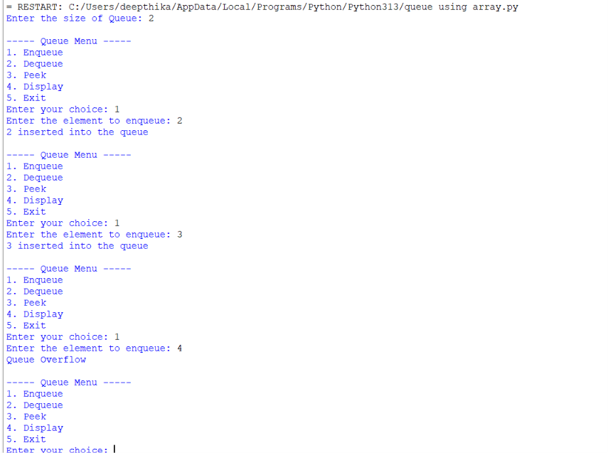
Explanation:
Queue Using Linked List
Structure:
- Each element is represented using a Node.
- Each Node contains:
  - data → stores the value.
  - next → points to the next node.
- self.front points to the first node.
- self.rear points to the last node.
- Initially:
  - front = None
  - rear = None
Operations:
1. Enqueue
- Create a new node.
- If the queue is empty:
  - Set both front and rear to the new node.
- Otherwise:
  - Link rear.next to the new node.
  - Update rear to the new node.
2. Dequeue
- Check if front is None → Underflow.
- Store/remove the node at front.
- Move front to front.next.
- If front becomes None, set rear = None.
3. Peek
- Shows the data stored at front without removing it.
- If front is None, the queue is empty.
4. Display
- Start from front.
- Traverse using next.
- Print each element until None.
Important Points:
- Follows FIFO.
- Insertion → rear.
- Deletion → front.
- No fixed size is required.
- Memory is allocated dynamically.
ERROR TABLE: QUEUE USING LINKED LIST
S.NO | Error Obtained | Rectification
1. | Display on empty queue. | Add condition: if self.front is None: → print "Queue is empty".
2. | Queue Underflow when deleting from an empty queue. | Add a check: if self.front is None: → print "Queue Underflow".
3. | First node inserted without updating front and rear. | If the queue is empty, set self.front = self.rear = new.
4. | rear not updated after insertion. | Update using self.rear = new after linking the new node.

Program: Linked List

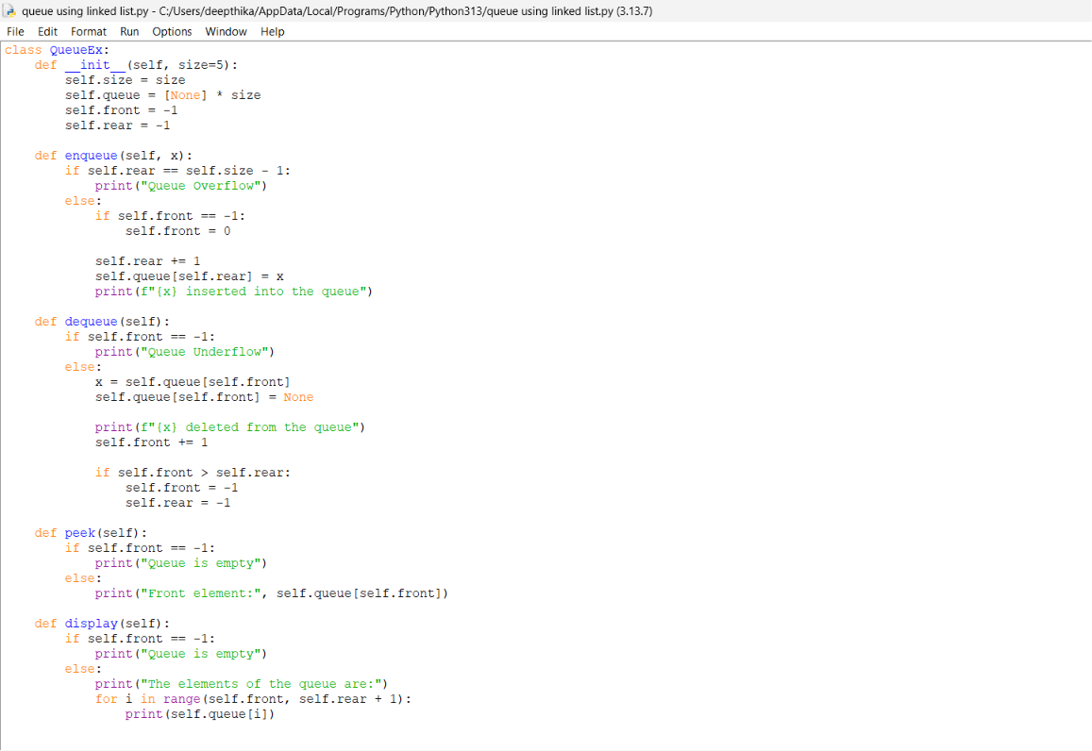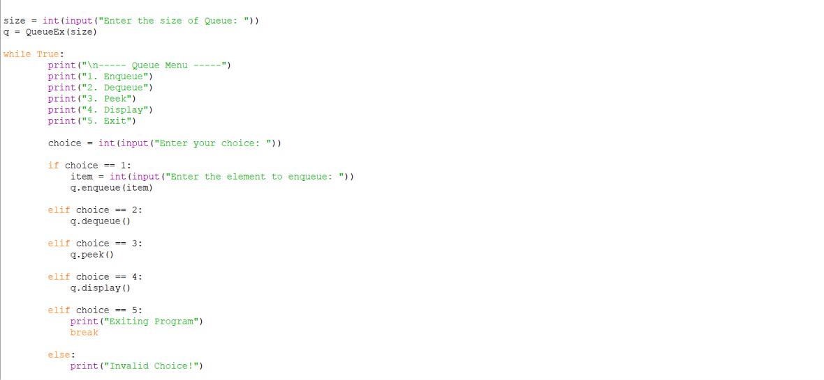
Output:
Positive case:

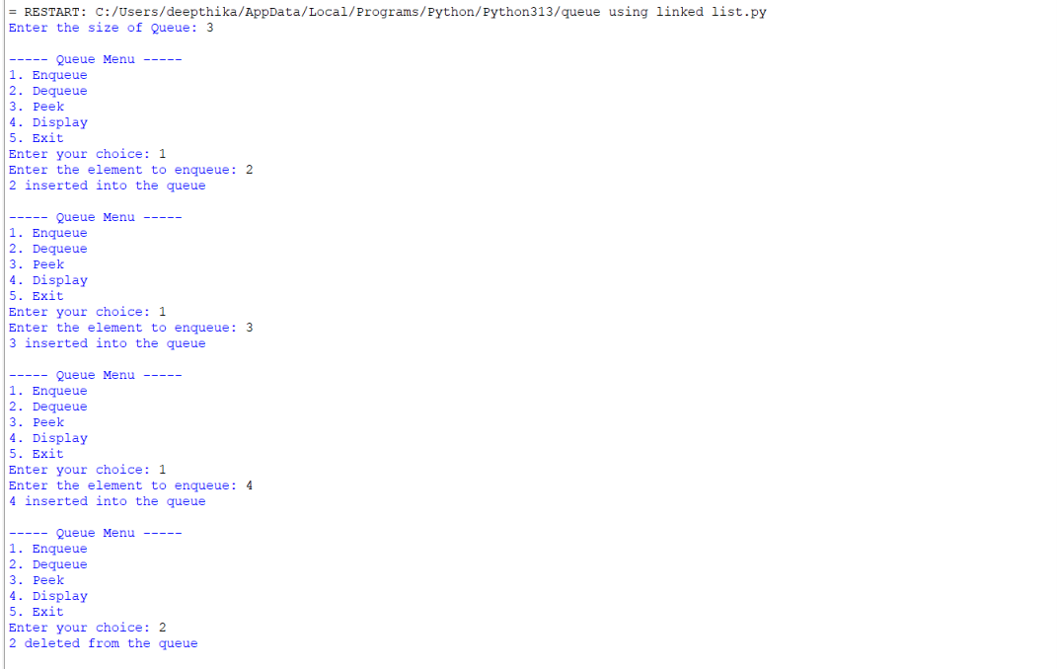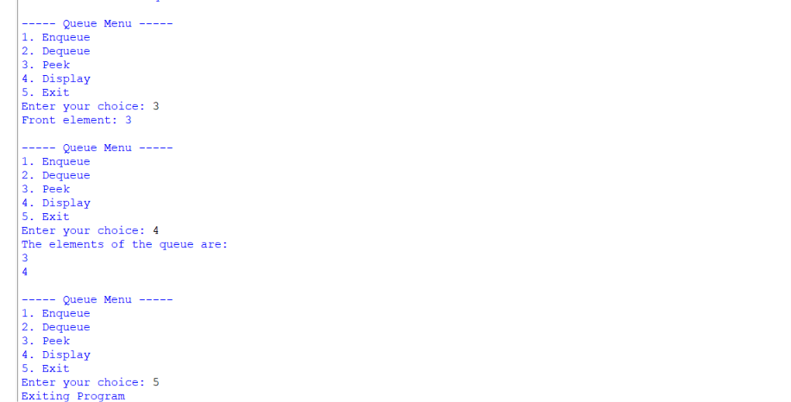
Negative case:

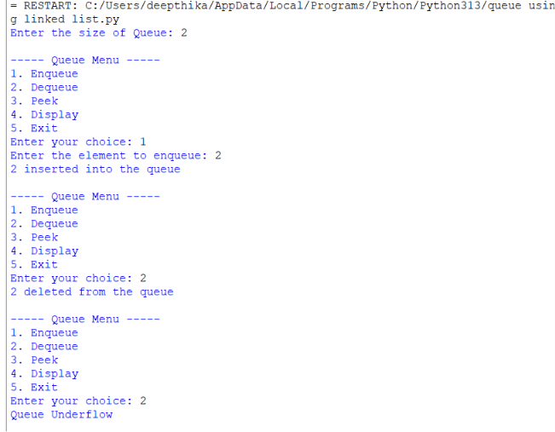
Explanation:
Circular Queue Using Array
Structure:
- Uses a Python list self.queue to store elements.
- self.front points to the first element.
- self.rear points to the last element.
- self.size defines the maximum capacity.
- When rear reaches the last index, it can wrap around to index 0.
- This allows previously freed positions to be reused.
Operations:
1. Enqueue
- Check if (rear + 1) % size == front → Overflow (circular queue is full).
- If the queue is empty:
  - Set front = 0
  - Set rear = 0
- Otherwise:
  - Move rear using:
rear = (rear + 1) % size
- Insert the element at rear.
2. Dequeue
- Check if front == -1 → Underflow.
- Remove the element at front.
- If front == rear:
  - The queue becomes empty.
  - Set front = -1 and rear = -1.
- Otherwise:
  - Move front using:
front = (front + 1) % size
3. Peek
- Shows the element at front without removing it.
- If front == -1, the queue is empty.
4. Display
- Start from front.
- Move towards rear.
- Use modulo % size to wrap around to the beginning of the array.
Important Points:
- Follows FIFO.
- Insertion → rear.
- Deletion → front.
- The last position connects logically back to the first position.
- Unused spaces can be reused, unlike a simple linear array queue.
- Overflow occurs when the next rear position becomes the front.
Error Table: QUEUE USING ARRAY
S.NO | Error Obtained | Rectification
1. | Display on empty queue. | Add condition: if self.front == -1: → print "Queue is empty".
2. | Queue Overflow when inserting beyond the defined size. | Add a check: if self.rear == self.size - 1: → print "Queue Overflow".
3. | Queue Underflow when deleting from an empty queue. | Add a check: if self.front == -1 or self.front > self.rear: → print "Queue Underflow".
4. | First element inserted without setting front. | If the queue is empty, set self.front = 0 before increasing rear.

Lab 7
AIM a)write a python program to implement binary search tree using an array with all its operations.
Program:

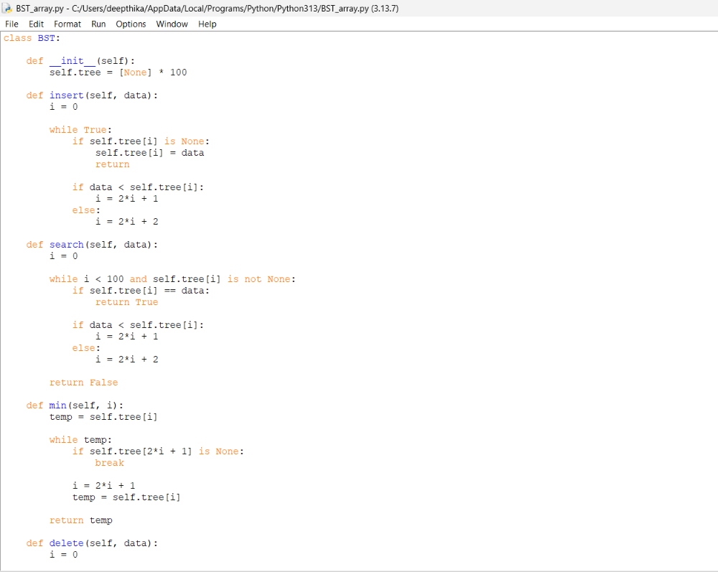
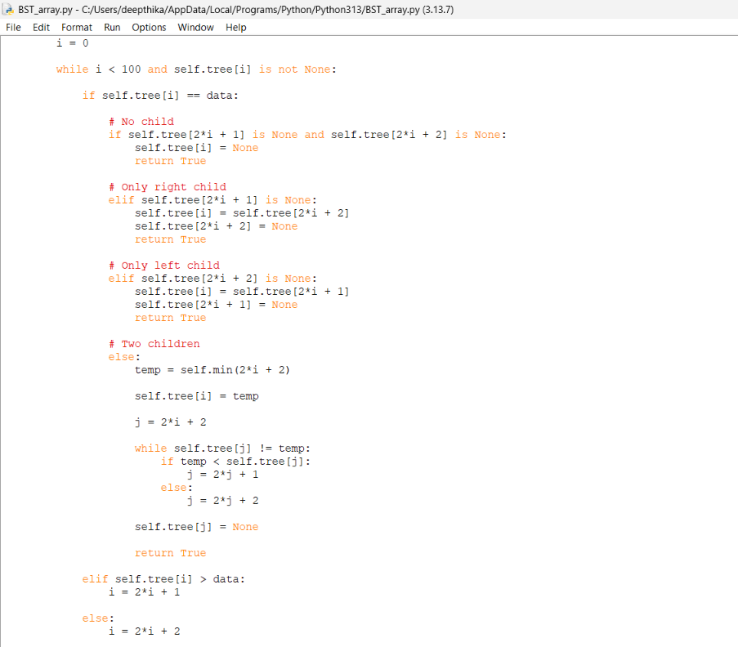
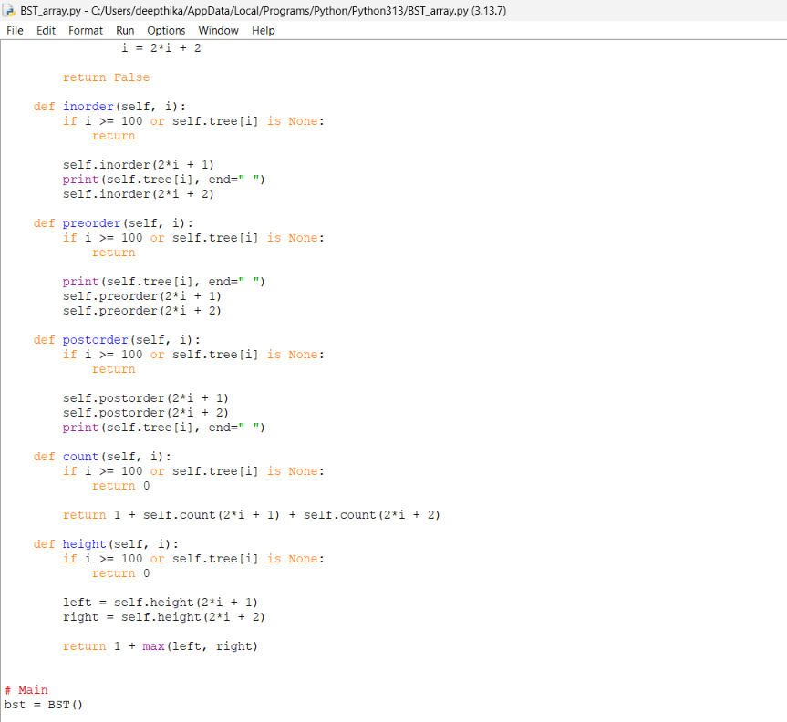
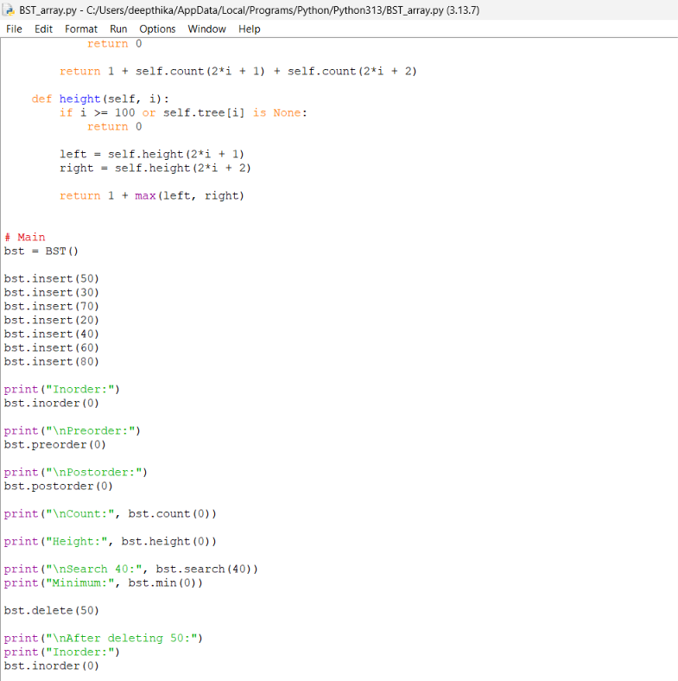output:

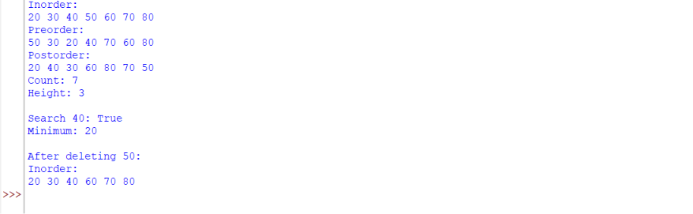
Explanation:
Binary Search Tree (BST) Using Array
Structure:
- Uses a Python list self.tree to store the elements.
- The root element is stored at index 0.
- For a node at index i:
  - Left child → 2*i + 1
  - Right child → 2*i + 2
- An empty position is represented using None.
- BST follows the rule:
  - Left subtree contains smaller elements.
  - Right subtree contains greater elements.
Operations:
1. Insert
- Start from index 0 (root).
- Compare the new element with the current element.
- If the element is smaller → move to 2*i + 1.
- If the element is greater → move to 2*i + 2.
- Continue until an empty position (None) is found.
- Insert the element at that position.
2. Search
- Start from the root.
- Compare the required element with the current element.
- If equal → element is found.
- If smaller → move to the left child.
- If greater → move to the right child.
- If None is reached → element is not present.
3. Delete
There are three cases:
- No child: Set that position to None.
- One child: Replace the node with its child.
- Two children: Find the minimum element in the right subtree (inorder successor), replace the deleted element with it, and remove the original successor.
4. Minimum
- Start from the given node.
- Keep moving to the left child.
- The leftmost element is the minimum value.
5. Maximum
- Start from the given node.
- Keep moving to the right child.
- The rightmost element is the maximum value.
6. Inorder Traversal
- Traverse Left → Root → Right.
- Inorder traversal of a BST gives elements in sorted order.
7. Preorder Traversal
- Traverse Root → Left → Right.
8. Postorder Traversal
- Traverse Left → Right → Root.
9. Count
- Counts the total number of nodes in the BST.
- Formula:
Count = 1 + left subtree count + right subtree count
10. Height
- Finds the longest path from the root to a leaf.
- Formula:
Height = 1 + max(left height, right height)
Important Points:
- Root is at index 0.
- Left child → 2*i + 1.
- Right child → 2*i + 2.
- None represents an empty position.
- Inorder traversal gives sorted elements.
- BST provides efficient searching when the tree is balanced.
Error Table:
S.NO | Error Obtained | Rectification
1. | Inserting into an occupied position without comparing the value. | Compare data with self.tree[i]. If data is smaller, move to 2*i + 1; otherwise move to 2*i + 2.
2. | Searching beyond the array limit. | Check the index condition: while i < 100 and self.tree[i] is not None.
3. | Searching for a value that does not exist. | If self.tree[i] is None, return False.
4. | Incorrect child index calculation. | Use left child = 2*i + 1 and right child = 2*i + 2.

AIM b) write a python program to implement binary tree using an linked list with all its operations.

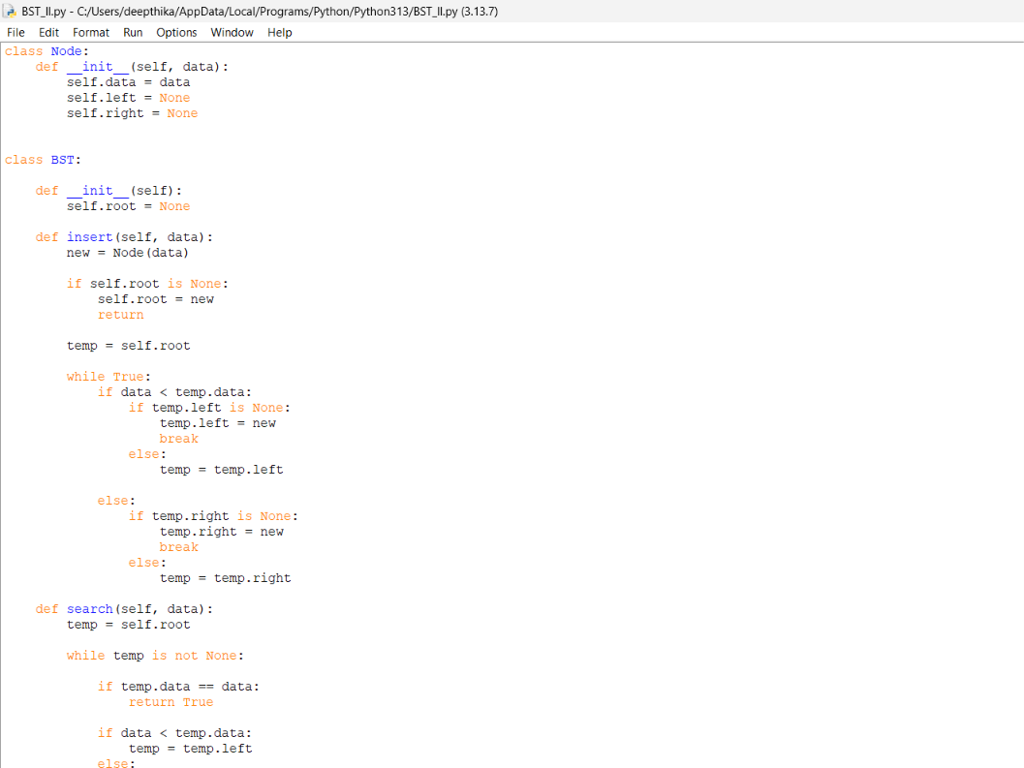
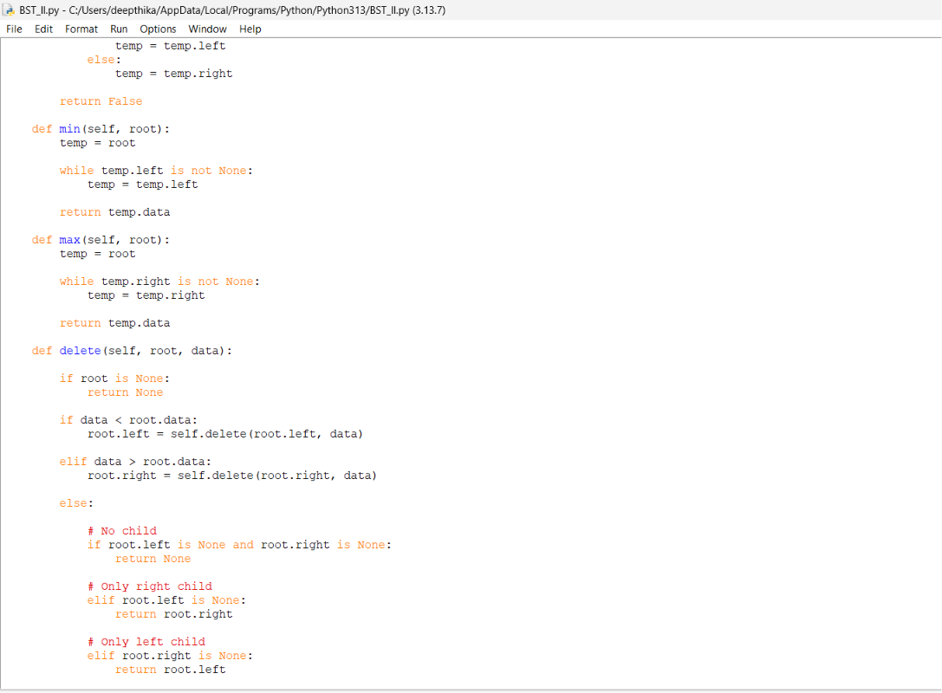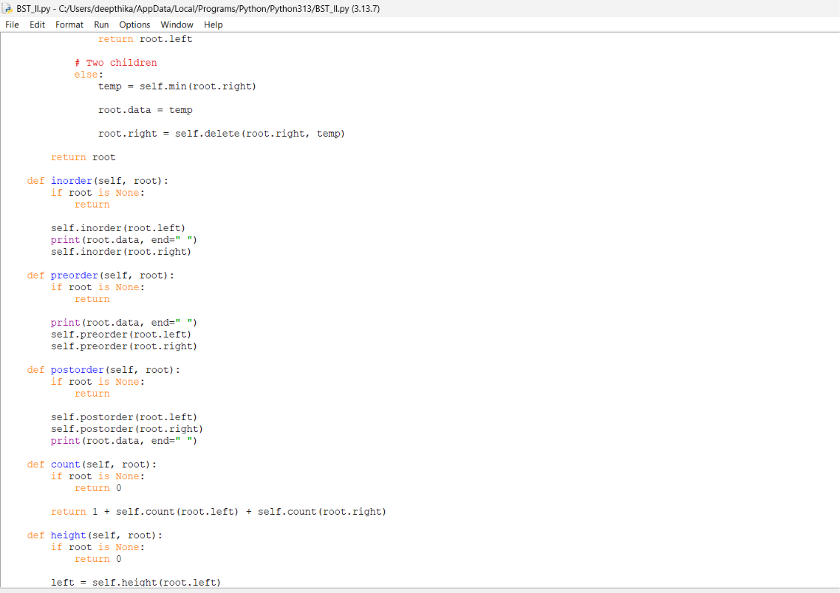
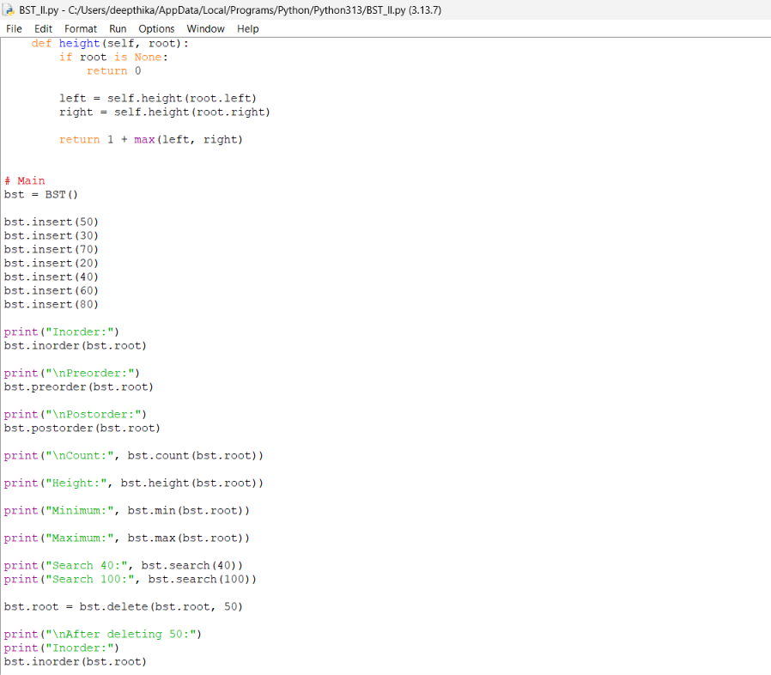

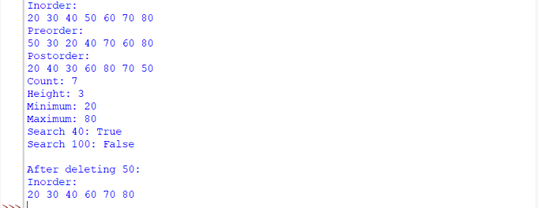
Explanation:
Binary Search Tree (BST) Using Linked List
Structure:
- Each element is represented using a Node.
- Each Node contains:
  - data → stores the value.
  - left → points to the left child.
  - right → points to the right child.
- self.root points to the root node of the BST.
- Initially, root = None, which means the tree is empty.
- BST follows the rule:
  - Left subtree contains smaller elements.
  - Right subtree contains greater elements.
Operations:
1. Insert
- Create a new node.
- If the tree is empty, make the new node the root.
- Otherwise, start from the root.
- If the new element is smaller → move to the left.
- If the new element is greater → move to the right.
- Continue until an empty position is found.
- Link the new node at that position.
2. Search
- Start from the root.
- Compare the required element with the current node.
- If equal → element is found.
- If smaller → move to the left child.
- If greater → move to the right child.
- If None is reached → element is not present.
3. Delete
There are three cases:
- No child: Remove the node.
- One child: Replace the node with its child.
- Two children: Find the minimum element in the right subtree (inorder successor), copy its value into the node, and delete the original successor node.
4. Minimum
- Start from the given node.
- Keep moving to the left child.
- The leftmost node contains the minimum value.
5. Maximum
- Start from the given node.
- Keep moving to the right child.
- The rightmost node contains the maximum value.
6. Inorder Traversal
- Traverse Left → Root → Right.
- Gives BST elements in sorted order.
7. Preorder Traversal
- Traverse Root → Left → Right.
8. Postorder Traversal
- Traverse Left → Right → Root.
9. Count
- Counts the total number of nodes.
- Formula:
Count = 1 + left subtree count + right subtree count
10. Height
- Finds the longest path from the root to a leaf.
- Formula:
Height = 1 + max(left height, right height)
Important Points:
- root points to the first node.
- left stores the reference to the left child.
- right stores the reference to the right child.
- None represents an empty child.
- Inorder traversal gives sorted elements.
- Linked-list representation uses dynamic memory.
Error table:
S.NO | Error Obtained | Rectification
1. | Inserting the first node without setting root. | If self.root is None, set self.root = new and return.
2. | Searching for a value that does not exist. | Continue while temp is not None; if temp becomes None, return False.
3. | Incorrect movement while searching. | If data < temp.data, move to temp.left; otherwise move to temp.right.
4. | Deleting a node with two children incorrectly. | Find the minimum value in the right subtree, replace the node data, and delete the successor.

LAB 8
Aim : write a python program to implement Binary tree with its operations using array and linked list.

Program: using array

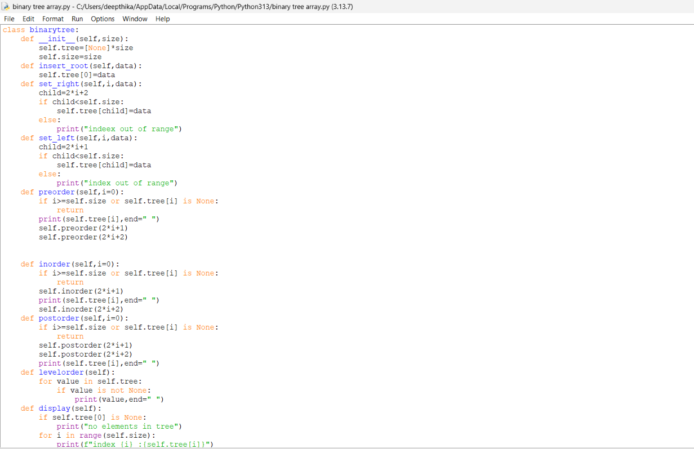

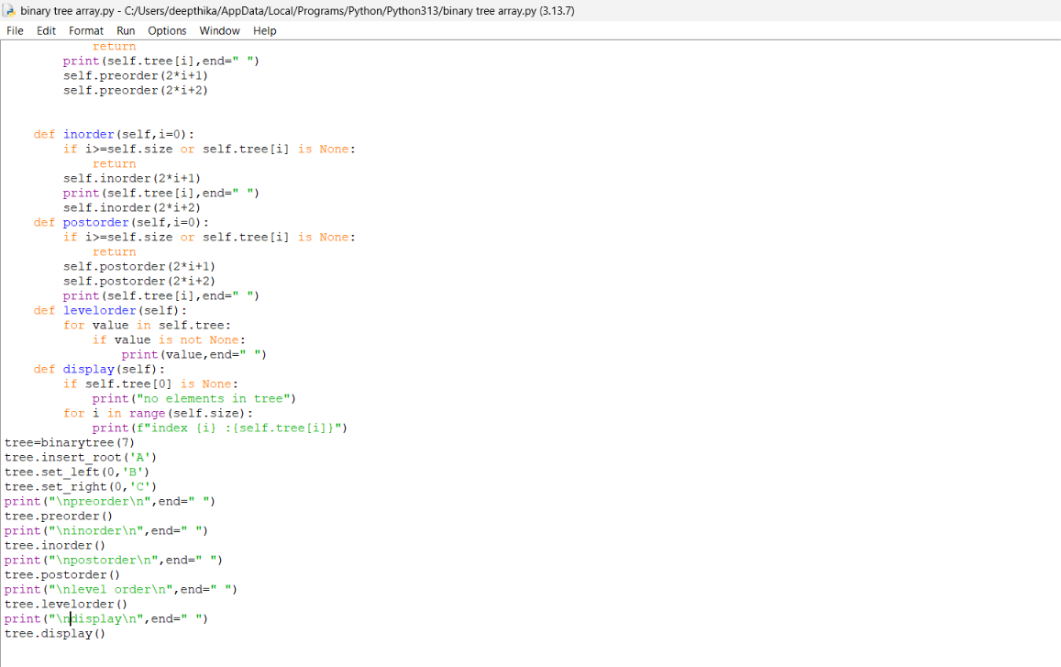
Output:

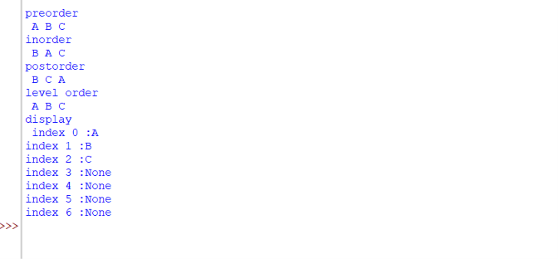
Explanation:
- The binarytree class is used to implement a binary tree using an array. The tree list is initialized with None values according to the given size.
- The insert_root() function stores the root node at index 0 because the root is always the first element in the array representation.
- The set_left() function is used to insert the left child of a node. For a node at index i, its left child is stored at index 2*i + 1.
- The set_right() function is used to insert the right child of a node. For a node at index i, its right child is stored at index 2*i + 2.
- The if child < self.size condition checks whether the calculated child index is within the available array size. If it exceeds the size, an index-out-of-range message is displayed.
- The preorder() function visits the current node first, followed by its left subtree and right subtree. The child indexes are calculated using 2*index + 1 and 2*index + 2.
- The inorder() function first visits the left subtree, then the current node and finally the right subtree.
- The postorder() function first visits the left subtree, then the right subtree and finally the current node.
- The levelorder() function visits the elements from the beginning to the end of the array. Since the array stores the binary tree level by level, this directly gives the level-order traversal.
- The display() function uses a loop to display every index of the array along with the value stored at that index.
- The condition self.tree[index] is None is used during traversal to stop when an empty position is reached.

Error Table:
S.No | Common Error | Correction
1 | Not setting left and right references to None while creating a node. | Initialize both left and right as None in the Node constructor.
2 | Calling traversal functions without passing the current node correctly. | Pass the current node during recursive calls.
3 | Forgetting the base condition when the current node is None. | Use a condition such as if root is None: return.
4 | Using the wrong traversal order. | Preorder: Root-Left-Right, Inorder: Left-Root-Right, Postorder: Left-Right-Root.

Program: using linked list

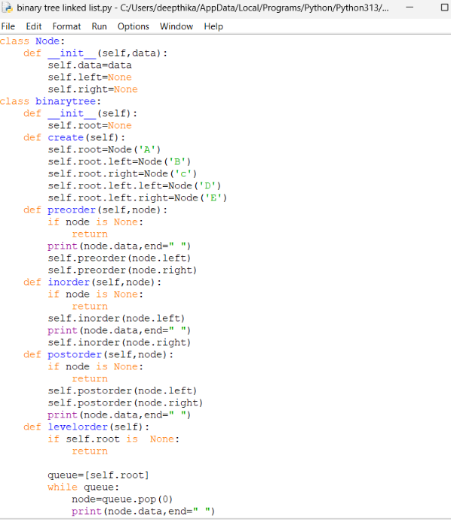
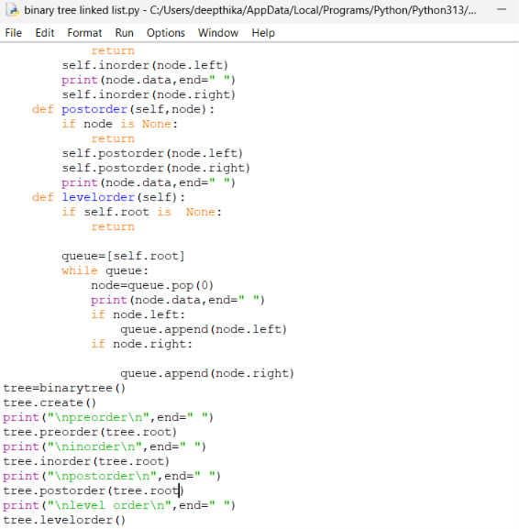
Output:

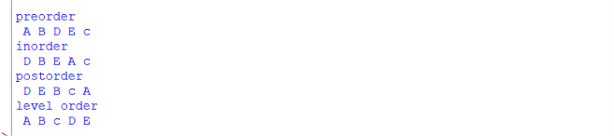
Explanation:
- The Node class is used to create each node of the binary tree. Each node contains three parts: data, left, and right. The data stores the value, while left and right store references to the left and right child nodes.
- The __init__() method initializes the node with the given data. Initially, both left and right are set to None because the node does not have any children.
- The root represents the first node of the binary tree. New nodes are connected to the root using the left and right references.
- The preorder() function performs preorder traversal. It first visits the root node, then recursively visits the left subtree and finally the right subtree. The order followed is Root → Left → Right.
- The inorder() function performs inorder traversal. It first visits the left subtree, then the root node and finally the right subtree. The order followed is Left → Root → Right.
- The postorder() function performs postorder traversal. It first visits the left subtree, then the right subtree and finally the root node. The order followed is Left → Right → Root.
- The condition if root: checks whether the current node exists. If the node is None, the recursive function stops for that particular branch.

Error Table:
S.No | Common Error | Correction
1 | Not setting left and right references to None while creating a node. | Initialize both left and right as None in the Node constructor.
2 | Calling traversal functions without passing the current node correctly. | Pass the current node during recursive calls.
3 | Forgetting the base condition when the current node is None. | Use a condition such as if root is None: return.
4 | Using the wrong traversal order. | Preorder: Root-Left-Right, Inorder: Left-Root-Right, Postorder: Left-Right-Root.

Lab 9
Aim : write a python code for AVL tree using array and linked list with all its operations.
Program:

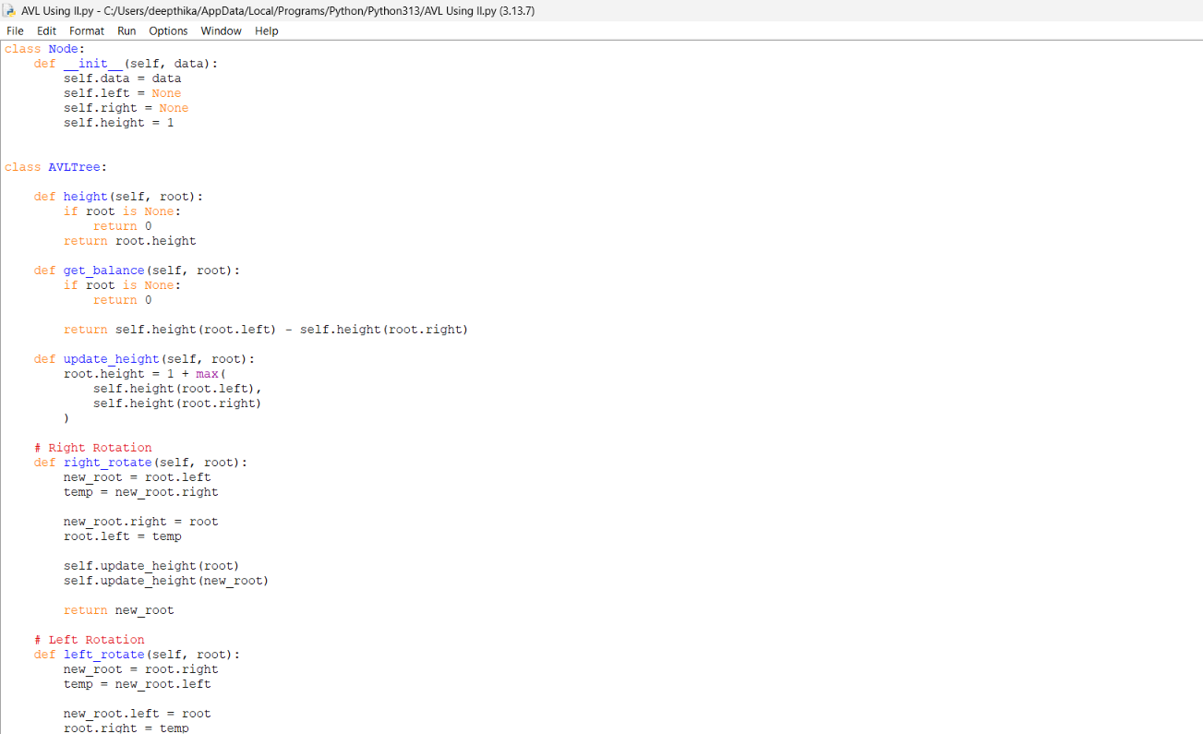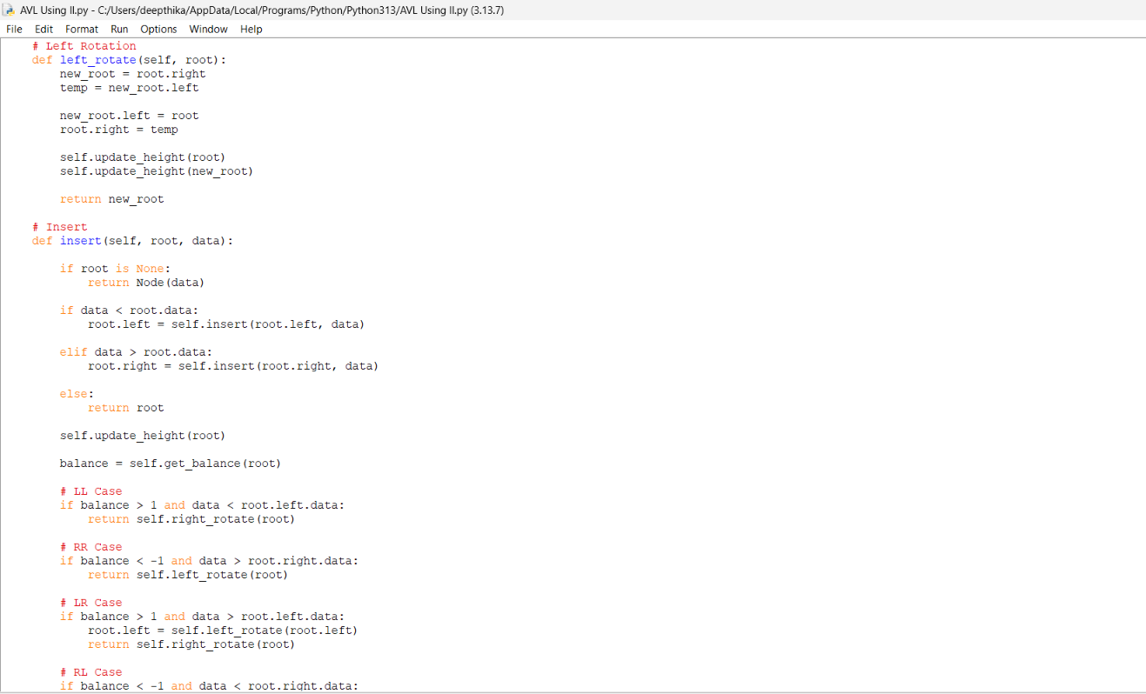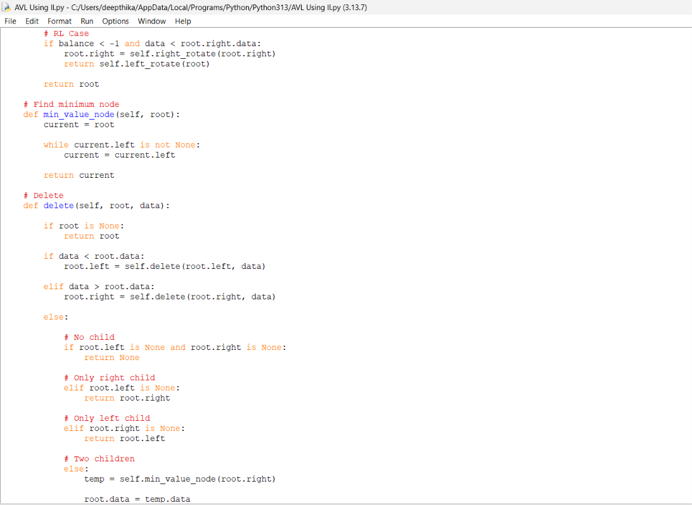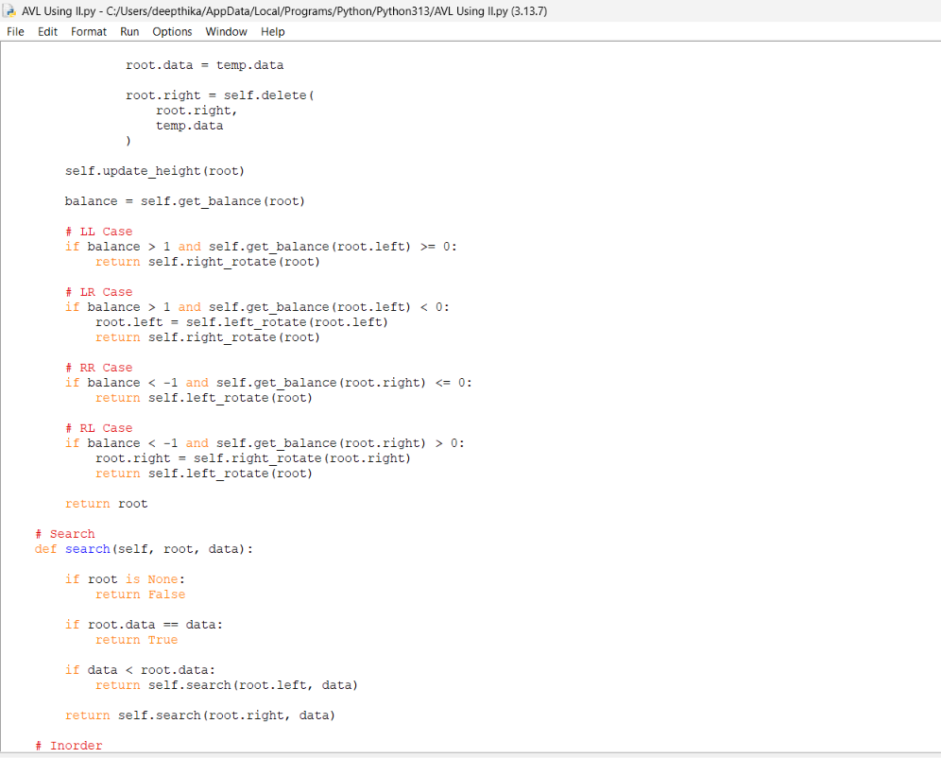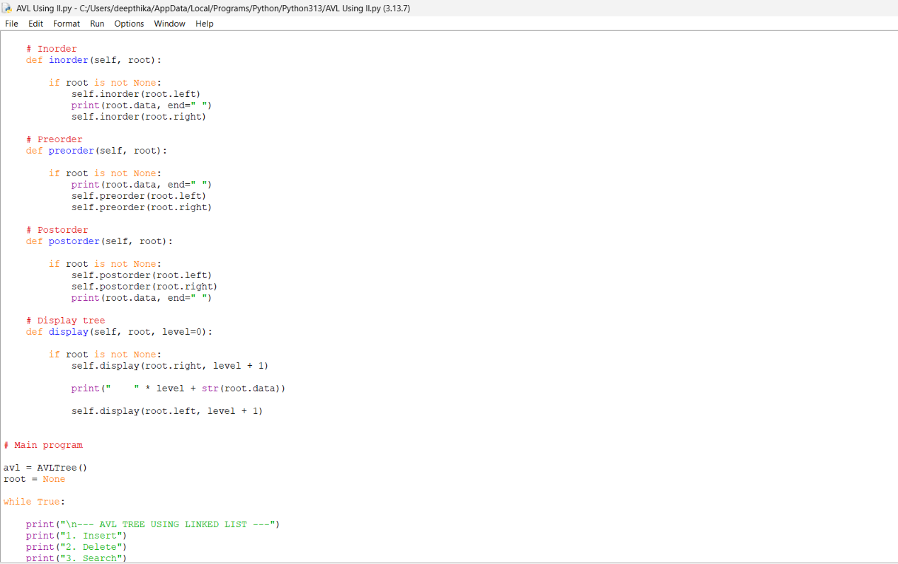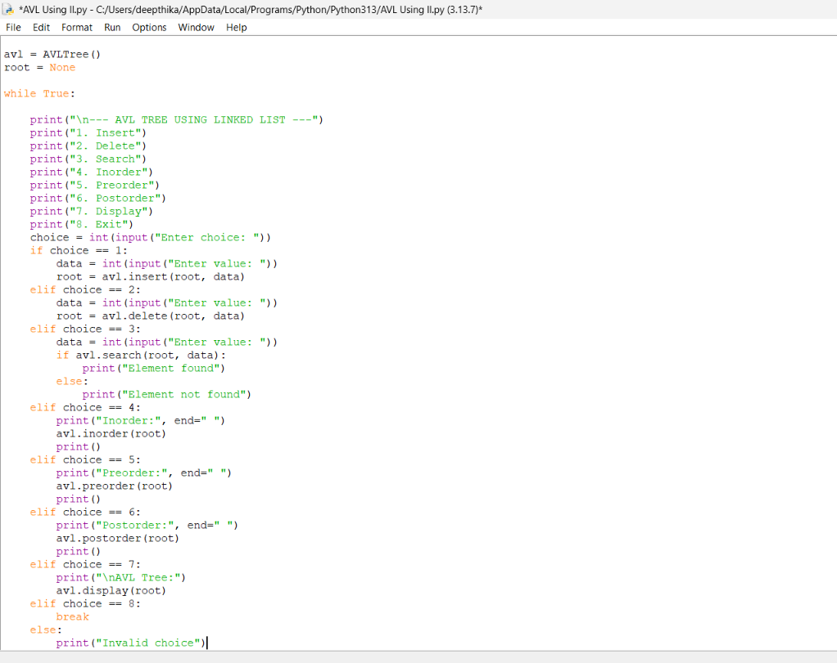
Output:
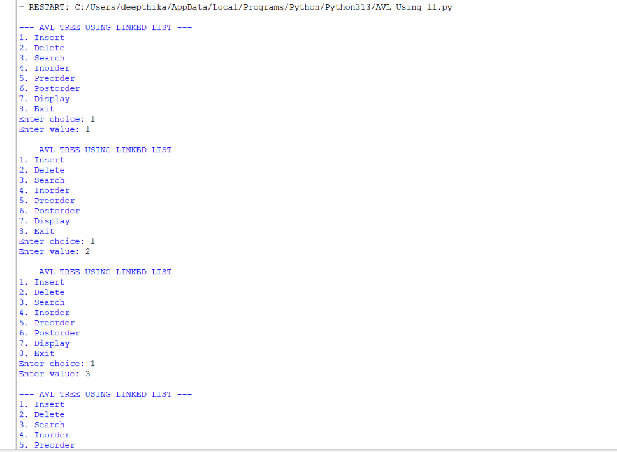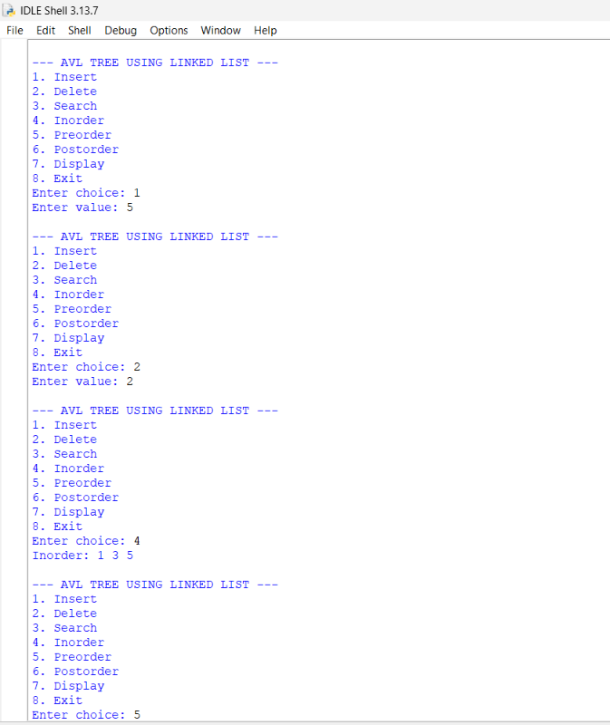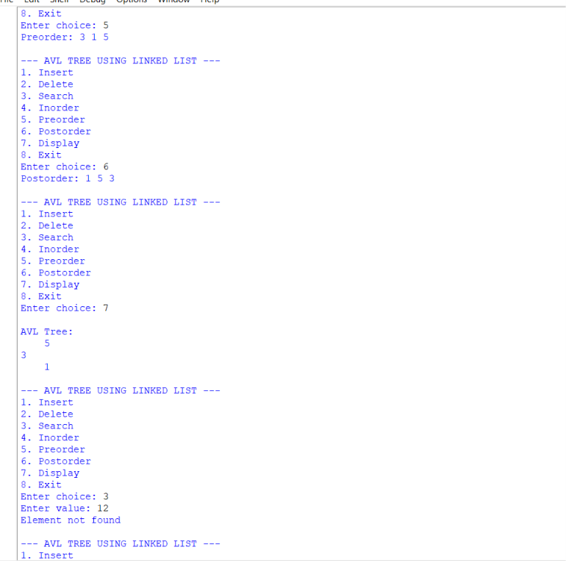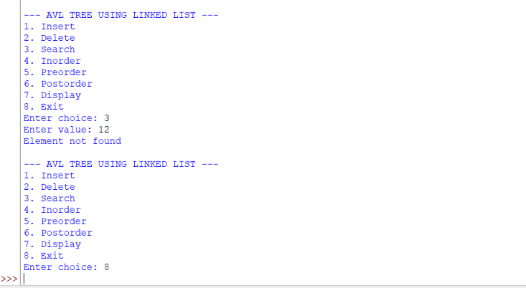
Explanation:
- An AVL tree is a self-balancing Binary Search Tree (BST).
- In an AVL tree, the difference between the height of the left and right subtrees is called the Balance Factor.
- The Balance Factor of every node must be -1, 0, or +1.
- In the array implementation, the tree nodes are stored inside a fixed-size array.
- For a node at index i:
  - Left child is stored at 2*i + 1.
  - Right child is stored at 2*i + 2.
- None is used to represent an empty position in the array.
Main Functions
- __init__()
  - Creates the array for storing the tree.
  - The size of the array is given by the user/program.
  - Initially, all positions contain None.
- height()
  - Calculates the height of a node.
  - It recursively checks the left and right subtrees.
  - The greater height is selected and 1 is added.
- balance_factor()
  - Calculates the balance factor of a node.
  - It is calculated as:
    - Height of Left Subtree - Height of Right Subtree
  - A value greater than 1 indicates that the tree is left-heavy.
  - A value less than -1 indicates that the tree is right-heavy.
- insert()
  - Adds a new element to the AVL tree.
  - The element is placed according to Binary Search Tree rules.
  - Smaller values are placed in the left subtree.
  - Larger values are placed in the right subtree.
  - After insertion, the tree is checked and rotations are performed if required.
- search()
  - Searches for a particular element.
  - If the element is found, it returns True.
  - If the element does not exist, it returns False.
- delete()
  - Removes an element from the tree.
  - It handles nodes with no child, one child, or two children.
  - After deletion, the tree is rebalanced.
- find_min()
  - Finds the smallest element in a subtree.
  - It repeatedly moves to the left child.
  - It is mainly used when deleting a node having two children.
- rotate_left()
  - Performs a left rotation when the tree becomes right-heavy.
  - It helps restore the AVL property.
- rotate_right()
  - Performs a right rotation when the tree becomes left-heavy.
  - It helps restore the AVL property.
- balance_tree()
  - Checks the balance factor of the nodes.
  - If the tree becomes unbalanced, suitable rotations are performed.
- inorder()
  - Traverses the tree in:
    - Left → Root → Right
  - It displays the elements in sorted order.
- preorder()
  - Traverses the tree in:
    - Root → Left → Right
- postorder()
  - Traverses the tree in:
    - Left → Right → Root
- display()
  - Displays the elements along with their array indexes.
  - It helps to understand how the tree is stored in the array.
Main Program
- The main program provides a menu-driven interface.
- The user can choose:
  - Insert
  - Delete
  - Search
  - Inorder
  - Preorder
  - Postorder
  - Display
  - Exit
- This allows all major AVL tree operations to be performed interactively.

2. AVL Tree Using Linked List – Explanation
- In the linked-list implementation, every tree element is represented using a Node.
- Each node contains:
  - Data
  - Left child
  - Right child
  - Height
- The left and right pointers connect the nodes and form the tree.
- Unlike the array implementation, memory is allocated dynamically as new nodes are created.
Node Class
- The Node class represents one node of the AVL tree.
- data stores the value.
- left stores the reference to the left child.
- right stores the reference to the right child.
- height stores the height of the node.
- Initially, a new node has height 1.
Main Functions
- height()
  - Returns the height of a node.
  - If the node is None, its height is considered 0.
- get_balance()
  - Calculates the balance factor.
  - Formula:
    - Height(Left) - Height(Right)
  - It is used to determine whether rotations are required.
- update_height()
  - Updates the height of a node after insertion, deletion, or rotation.
  - It takes the maximum height of the left and right subtrees and adds 1.
- right_rotate()
  - Performs a right rotation.
  - It is mainly used for the LL imbalance.
  - The left child becomes the new root of that subtree.
- left_rotate()
  - Performs a left rotation.
  - It is mainly used for the RR imbalance.
  - The right child becomes the new root of that subtree.
- insert()
  - Inserts a new value according to BST rules.
  - Smaller values go to the left.
  - Larger values go to the right.
  - The height of each affected node is updated.
  - The balance factor is checked.
  - If the tree becomes unbalanced, the appropriate rotation is performed.
Four Cases During Insertion
- LL Case
  - New node is inserted into the left subtree of the left child.
  - A right rotation is performed.
- RR Case
  - New node is inserted into the right subtree of the right child.
  - A left rotation is performed.
- LR Case
  - New node is inserted into the right subtree of the left child.
  - First, a left rotation is performed on the left child.
  - Then, a right rotation is performed.
- RL Case
  - New node is inserted into the left subtree of the right child.
  - First, a right rotation is performed on the right child.
  - Then, a left rotation is performed.
- min_value_node()
  - Finds the node with the minimum value.
  - It keeps moving to the left until the left child is None.
  - It is used during deletion of a node with two children.
- delete()
  - Deletes a node from the AVL tree.
  - Three situations are handled:
    - Node has no child.
    - Node has one child.
    - Node has two children.
  - For two children, the inorder successor is used.
  - After deletion, heights are updated.
  - The balance factor is checked and rotations are performed if required.
- search()
  - Searches for a given value.
  - If the value matches the current node, it returns True.
  - If the value is smaller, it searches the left subtree.
  - If the value is larger, it searches the right subtree.
- inorder()
  - Traverses:
    - Left → Root → Right
  - Produces the elements in sorted order.
- preorder()
  - Traverses:
    - Root → Left → Right
- postorder()
  - Traverses:
    - Left → Right → Root
- display()
  - Displays the tree structure vertically.
  - It helps visualize the relationship between parent and child nodes.
Main Program
- The main program creates an AVL tree object.
- root = None represents an initially empty tree.
- A menu is provided to perform different operations.
- The user can perform:
  - Insert
  - Delete
  - Search
  - Inorder
  - Preorder
  - Postorder
  - Display
  - Exit
Error Table:
S.No. | Common Error | Reason / Correction
1 | AttributeError: NoneType | The code tries to access a property of an empty node. Check whether the node is None before accessing its data or children.
2 | Incorrect rotation | The left/right child references are changed incorrectly. Verify the temporary node and child links during rotation.
3 | Wrong height or balance factor | The height is not updated after insertion, deletion, or rotation. Call the height update function at the correct place.
4 | Element not found during deletion/search | The value does not exist in the tree or the search path is incorrect. Follow BST comparison rules correctly.

Program:
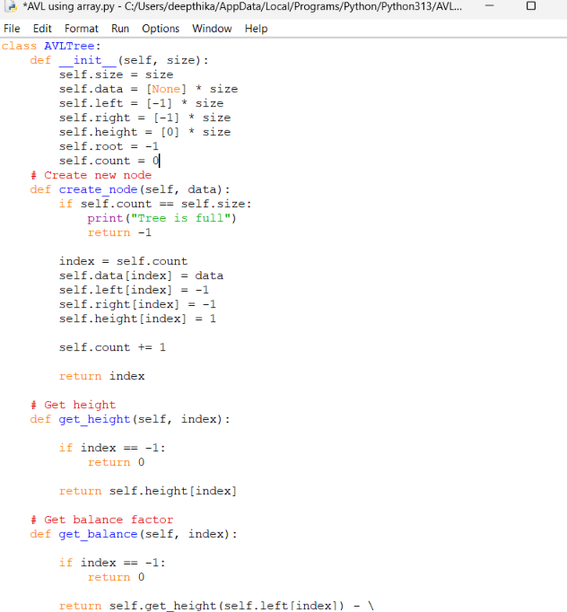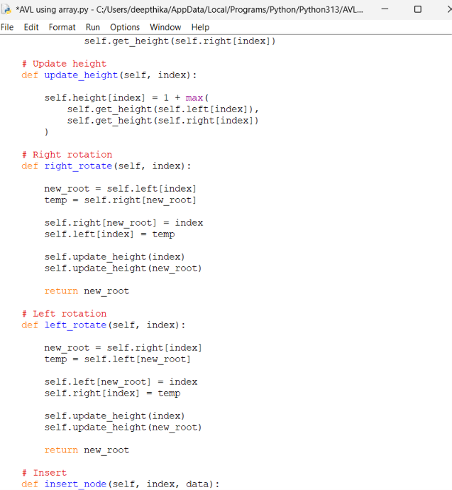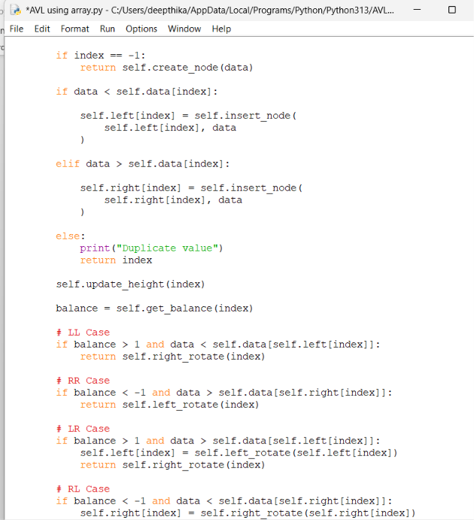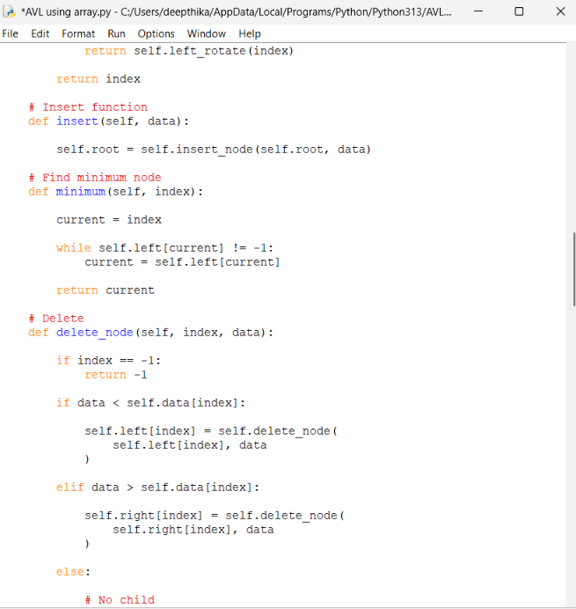
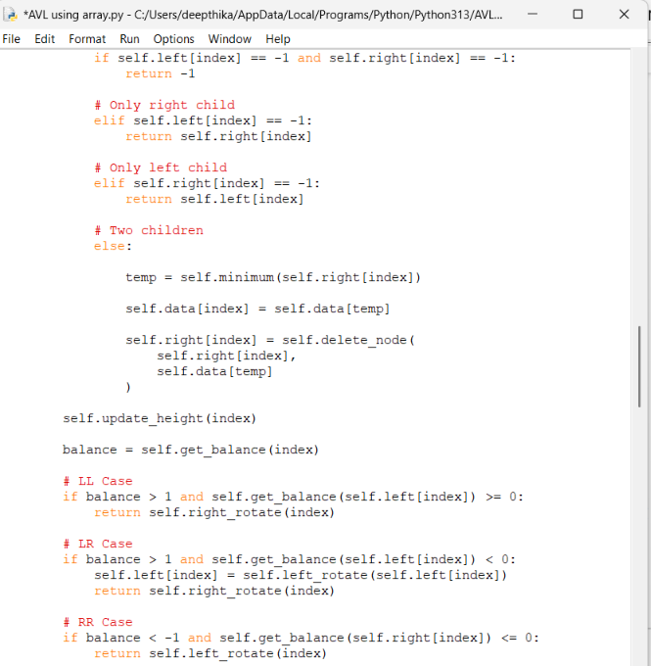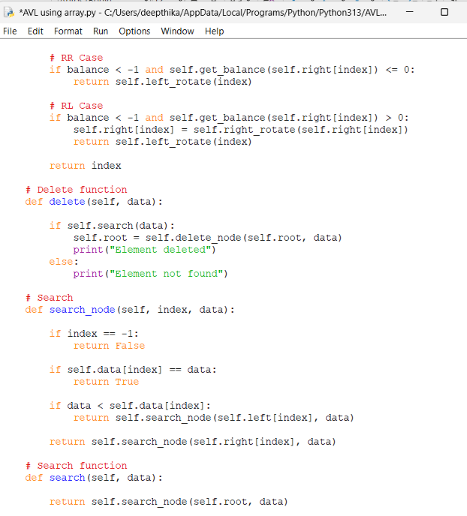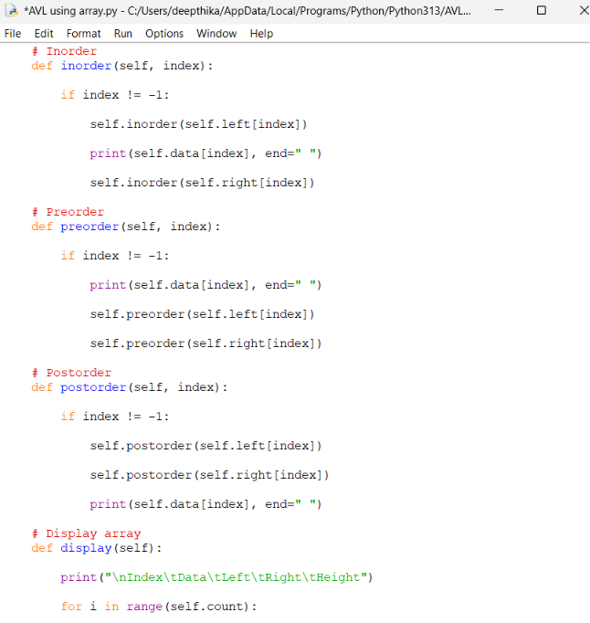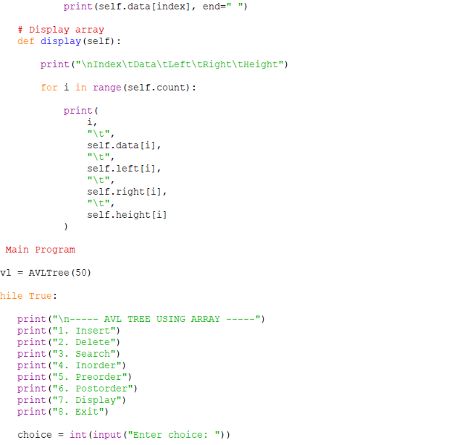
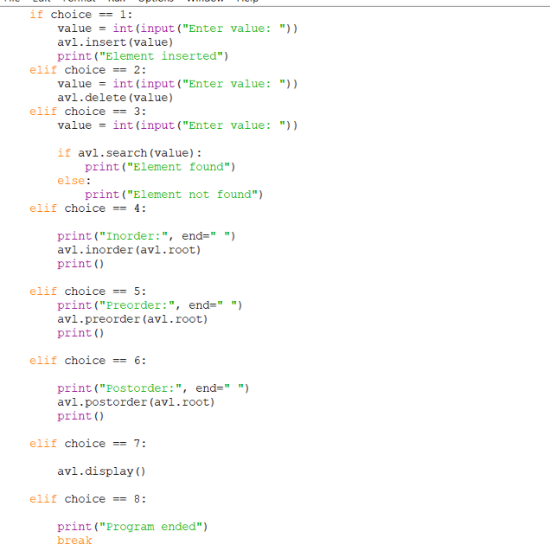
Output:
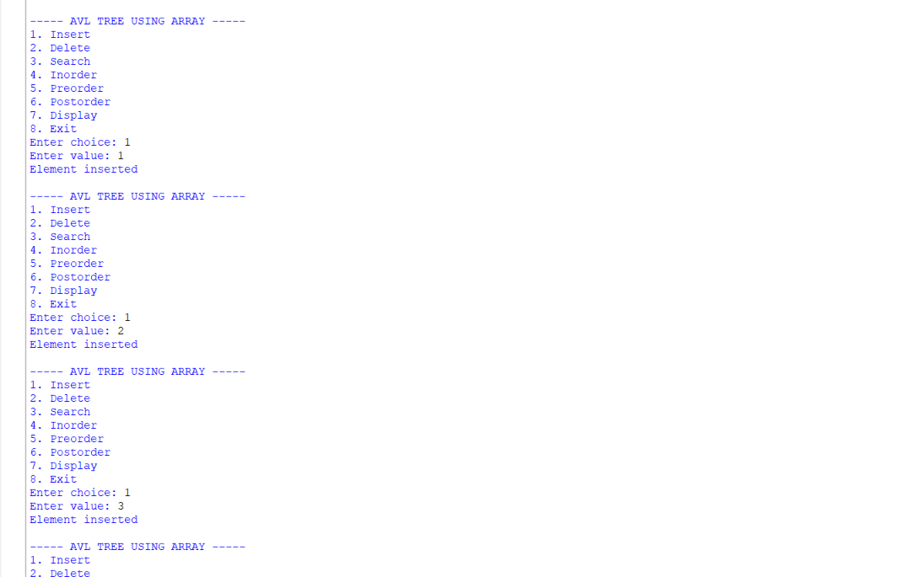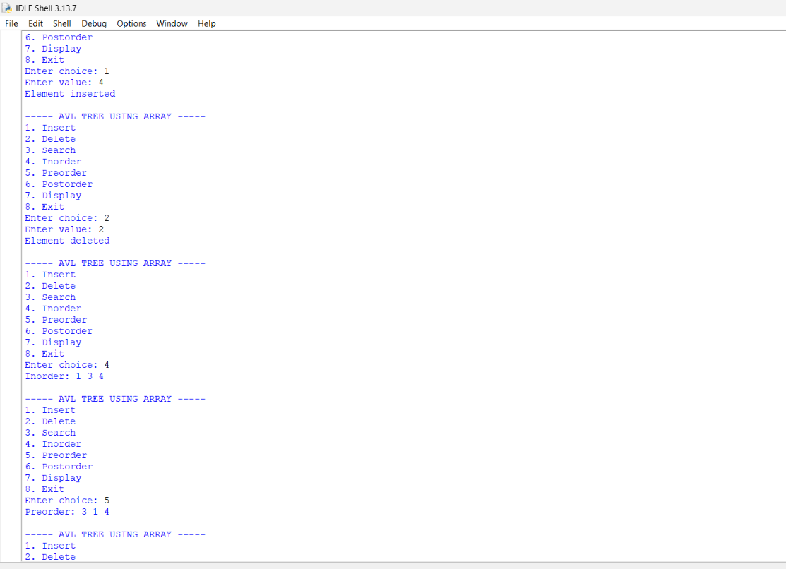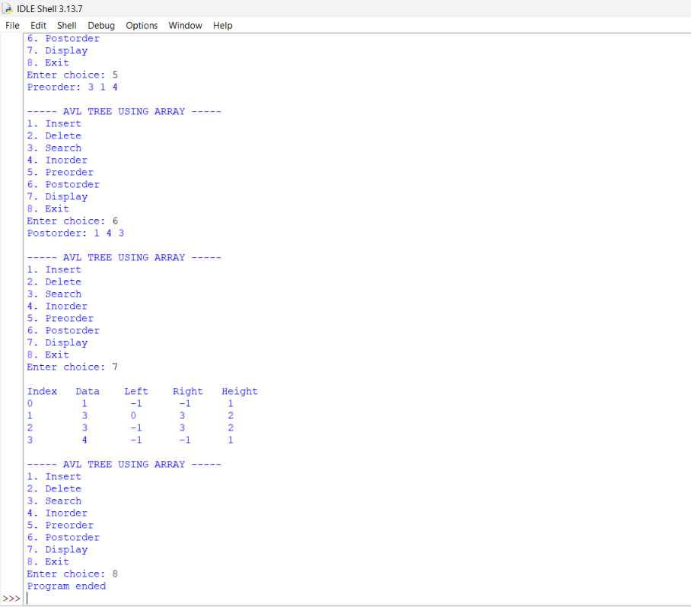
Explanation:
- An AVL tree is a self-balancing Binary Search Tree (BST).
- In an AVL tree, the difference between the height of the left and right subtrees is called the Balance Factor.
- The Balance Factor of every node must be -1, 0, or +1.
- In the array implementation, the tree nodes are stored inside a fixed-size array.
- For a node at index i:
  - Left child is stored at 2*i + 1.
  - Right child is stored at 2*i + 2.
- None is used to represent an empty position in the array.
Main Functions
- __init__()
  - Creates the array for storing the tree.
  - The size of the array is given by the user/program.
  - Initially, all positions contain None.
- height()
  - Calculates the height of a node.
  - It recursively checks the left and right subtrees.
  - The greater height is selected and 1 is added.
- balance_factor()
  - Calculates the balance factor of a node.
  - It is calculated as:
    - Height of Left Subtree - Height of Right Subtree
  - A value greater than 1 indicates that the tree is left-heavy.
  - A value less than -1 indicates that the tree is right-heavy.
- insert()
  - Adds a new element to the AVL tree.
  - The element is placed according to Binary Search Tree rules.
  - Smaller values are placed in the left subtree.
  - Larger values are placed in the right subtree.
  - After insertion, the tree is checked and rotations are performed if required.
- search()
  - Searches for a particular element.
  - If the element is found, it returns True.
  - If the element does not exist, it returns False.
- delete()
  - Removes an element from the tree.
  - It handles nodes with no child, one child, or two children.
  - After deletion, the tree is rebalanced.
- find_min()
  - Finds the smallest element in a subtree.
  - It repeatedly moves to the left child.
  - It is mainly used when deleting a node having two children.
- rotate_left()
  - Performs a left rotation when the tree becomes right-heavy.
  - It helps restore the AVL property.
- rotate_right()
  - Performs a right rotation when the tree becomes left-heavy.
  - It helps restore the AVL property.
- balance_tree()
  - Checks the balance factor of the nodes.
  - If the tree becomes unbalanced, suitable rotations are performed.
- inorder()
  - Traverses the tree in:
    - Left → Root → Right
  - It displays the elements in sorted order.
- preorder()
  - Traverses the tree in:
    - Root → Left → Right
- postorder()
  - Traverses the tree in:
    - Left → Right → Root
- display()
  - Displays the elements along with their array indexes.
  - It helps to understand how the tree is stored in the array.
Main Program
- The main program provides a menu-driven interface.
- The user can choose:
  - Insert
  - Delete
  - Search
  - Inorder
  - Preorder
  - Postorder
  - Display
  - Exit
- This allows all major AVL tree operations to be performed interactively.
Error table:
S.No. | Common Error | Reason / Correction
1 | Index out of range | The calculated child index exceeds the array size. Use a sufficiently large array and check the index before accessing it.
2 | Tree becomes full | The fixed-size array has no empty position available. Increase the array size.
3 | Incorrect child index | Using the wrong formula for child positions causes incorrect tree structure. Use left = 2*i+1 and right = 2*i+2.
4 | Incorrect balancing after insertion/deletion | The balance factor or rotation is not handled correctly. Check the balance factor and perform the required rotation.

